**SOFTWARE ENGINEERING PROJECT REPORT**

**Master Typing**



**Group 8 :**

**Hannah Gracia 1906381546**

**Lazaruslie Karsono 1906300782**

**Salma Shafira 1906300832**

**DEPARTMENT OF ELECTRICAL ENGINEERING**

**UNIVERSITY OF INDONESIA**

**2021**

**PREFACE**

We are very grateful to The God’s blessings that we are able to complete this report about our group project, “Master Typing”. This report is made to be part of RPL assignment, so that the process of building the project can be recorded. This project is built with a purpose to help people to improve their ability to type faster. We feel that this skill is important, especially nowadays when the computer is the main tool for work. Because the computer needs a keyboard to input words and numbers, typing faster can help to get the job done faster.

In this report, we specify our project aim, planning, management, UML diagrams, and the result. Also, we include the contract we made with our client to test the application, with the user manual to guide the users on how to operate the application within their localhost. All of the parts that were mentioned above are written in a similar order as our practice to build this project.

We hope that through this report, readers can gain more insight about the process of developing “Master Typing” project. We also apologize for any mistakes and deficiencies found in this report. We always welcome any constructive critics to help us grow.

**Table of Contents**

**List of Tables** **5**

**List of Figures** **6**

**CHAPTER I** **8**

**INTRODUCTION** **8**

Background 8

Project Description 8

Project Aim 9

Literature Review 9

Similar Competitor 11

Functions/Modules 11

Tools 12

Resources 13

Risk Analysis 14

Roles And Responsibilities 15

**CHAPTER II** **16**

**SOFTWARE PROJECT MANAGEMENT** **16**

2.1 Time Schedule 16

2.2 Risk Analysis 17

SURAT PERJANJIAN KONTRAK 18

**CHAPTER III** **25**

**UNIFIED MODELING LANGUAGE AND DESIGN** **25**

3.1 UML Diagrams 25

3.2 Database Diagram 29

**CHAPTER IV** **32**

**Implementation** **32**

**CHAPTER V** **41**

**Unit Testing** **41**

Software Test Plan 41

Objectives 41

Tasks 42

Tactics 43

Test Coverages 43

Test Methods 44

Test Responsibilities 45

Test Plan Types 45

Testing Strategy 45

Unit Testing 46

System and Integration Testing 47

Questionnaire Result 47

Hardware Requirement 52

**CHAPTER VI** **53**

**User Manual** **53**

**CHAPTER VII** **60**

**Closing** **60**

**REFERENCES** **60**

# List of Tables

# 

Table 1.1 Roles of each group member 15

Table 2.1 Project time schedule management 16

Table 5.1 Objectives 41

Table 5.2 Task 42

Table 5.3 Tactics 43

Table 5.4 Test Methods 44

Table 5.5 Unit Testing 46

Table 5.6 System and Integration Testing 47

# 

# List of Figures

# 

**CHAPTER III**

Fig. 3.1 Activity Diagram 25

Fig. 3.2 Use Case Diagram 26

Fig. 3.3 Sequence Diagram 27

Fig. 3.4 Collaboration Diagram 28

Fig. 3.5 ERD Diagram 29

Fig. 3.6 UML Diagram 30

**CHAPTER IV**

Fig. 4.1 Timer and box 32

Fig 4.2 Retrieve words from database 32

Fig 4.3 Input box 33

Fig 4.4 Score 33

Fig 4.5 Error and accuracy 33

Fig 4.6 Keystroke Function 34

Fig 4.7 Span and text color 34

Fig 4.8 InputType function 35

Fig 4.9 Display function 36

Fig 4.10 Main interface 37

Fig 4.11 Sign up interface 37

Fig 4.12 Sign in interface 38

Fig 4.13 Lobby-games interface 38

Fig 4.14 Lobby-language interface 39

Fig 4.15 Speed typing-game interface 39

Fig 4.16 Gibberish-game interface 40

Fig 4.17 Result interface 40

**CHAPTER V**

Fig 5.1 Result 1 47

Fig 5.2 Result 2 48

Fig 5.3 Result 3 48

Fig 5.4 Result 4 48

Fig 5.5 Result 5 49

Fig 5.6 Result 6 49

Fig 5.7 Result 7 49

Fig 5.8 Result 8 50

Fig 5.9 Result 9 50

Fig 5.10 Result 10 50

Fig 5.11 Result 11 51

Fig 5.12 Result 12 51

Fig 5.13 Result 13 51

**CHAPTER VI**

Fig 6.1 User manual 1 53

Fig 6.2 User manual 2 53

Fig 6.3 User manual 3 54

Fig 6.4 User manual 4 54

Fig 6.5 User manual 5 54

Fig 6.6 User manual 6 55

Fig 6.7 User manual 7 55

Fig 6.8 User manual 8 56

Fig 6.9 User manual 9 56

Fig 6.10 User manual 10 56

Fig 6.11 User manual 11 57

Fig 6.12 User manual 12 57

Fig 6.13 User manual 13 58

Fig 6.14 User manual 14 58

Fig 6.15 User manual 15 58

Fig 6.16 User manual 16 59

# 

# CHAPTER I

# INTRODUCTION

This chapter is an introduction for Master Typing website development project. The background behind the project idea, the aim of the project, literature review, the analysis for the possible competitors, the functions/modules in the project, the tools being used, the human resource description, and the risk analysis for this project are all included in this introduction chapter.

## Background

In this era when every aspect of human activities incorporate technology, efforts to keep up with the development of technology are needed to make lives easier. There are many modern automated machines within the household to help do the chores efficiently with quick results, but those machines can only be used if the users know how to use them, which involves basic technological knowledge. Moreover, whenever people want to seek jobs in corporate offices, organizations usually require their employees to be proficient in using word and data processing software.

Software is a set of instructions that reside in computers to enable them to perform certain tasks. All computers need software to be able to process the tasks given by users, or else it will be useless. For example, operating systems like Windows, Linux, and iOS are essential to run the programs installed in a computer, all while processing inputs made by its user. In order to fully make use of a computer with its extensive abilities, users first need to be able to operate important main devices used for giving inputs into a computer, like mouse and keyboard. Keyboard is particularly used for inputting words, symbols, and numbers in word and data processing software. Typing fast on a keyboard will certainly get the job done quicker, resulting in more efficient way to spend time in a productive manner.

## Project Description

Master Typing is a web-based typing game, where players have to type quickly the words or sentences contained in the game. There is a timer to calculate the player's typing speed. The game will be finished when the player finishes typing the available words or sentences or the available time timer runs out. The output or result of this game is that the player can find out the speed of typing the words per minute that the player has done.

## Project Aim

Master Typing project has the following objectives:

* To help people practice typing faster while maintaining the accuracy of each stroke
* To analyze the statistic data of users’ typing accuracy and time to categorize the typing ability
* To help people get familiar with programming syntax while practicing faster typing

## Literature Review

Internet usage has increased over time, especially when COVID-19 pandemic struck the world. People that could no longer roam the city freely to seek entertainment on the weekends, began searching for other alternatives to pass their free time. Those alternatives include internet, and internet is the most frequent choice to fulfill that sole purpose. All websites on the internet are not only made to retrieve information from a server, but also required to have nice design to accomodate easier access and easy-to-use environment for their users.

Nearly all website-based applications, including other projects with similar category (typing practice) are designed with interesting and engaging interface for users. Poorly designed websites can actually be confusing to visitors, making them frustrated and not willing to deeper explore the website. Within a certain design, there are some elements which are essential to make a website easy to navigate and organized looking. Although a lot of the definition approach for website design elements can be overlapped, there are no standards currently defining the guidelines to effectively design a website. However, there are some studies referring to those key elements to include the user engagement side within a design so that the best practice can be followed.

Below are seven key design elements regarding a website design in user engagement segment:

1. Navigation

Ease of navigation across a website is a must, so that users do not feel lost and confused during their visit. Proper categorization and consistency of navigation bar should be present in all parts of the website. Search bar for easier find is extremely helpful, and visible links from a min site to particular subdomains and pages should be visible to navigate across bigger/smaller categories.

1. Graphical Representation

Use of images to illustrate contents of a page will add more color to a website, following a theme provided for it, including animation. However, the use of color should not overwhelm the content provided and the white space within a certain page, so that it is informative and attractive at the same time. A website also needs a distinct logo that represents its creator, so that users can easily identify and remember the website.

1. Organization

Organized website should have a solid structure and proper hierarchy between a main site and its subdomain. Moreover, all information should be arranged with systematic and proper categorization. All labels should briefly describe what the content is about.

1. Content Utility

Information content from a website should fulfill the users’ need without compromising the quality and motivation to further go deeper into the site. The content also needs to be relevant and updated regularly to keep users visiting the site repeatedly.

1. Purpose

Purpose of a website should include unique identity (including logo) and interactive type of interaction to keep the users entertained. On the website, information of the organization who built the website should be visible at all times, so that the visitors know whether the website is legitimate or not.

1. Simplicity

This part is important to make users’ visits less complicated and faster at finding information. In order to do so, a website layout should be concise and eliminate redundant features. All functions in a website should be easily understandable, so that the website is easy to be accessed, even by first time users.

1. Readability

The information written on a webpage should be easy to read and use proper grammar in order to be understandable. On each page, information content should not be too long or too short, resulting in reduced benefits/information that can be obtained from the page.

## Similar Competitor

The development projects that we make actually have many variations on other people's projects or websites or applications, for example, KazTyping, Typing10Fingers, TypeRacer, TypeShark, etc. Typing10Finger and TypeRacer which are two projects that are quite similar to ours, which are website-based and each have their own characteristics, both in terms of features and appearance of the website.

TypeRacer is one of the multi-user typing websites in its game, so the advantage over TypeRacer is that there is a comparative analysis with other users so that users will know how far their typing skills have reached when compared to other users. The characteristics that Typing10Fingers have are the keystrokes and calculation of the words (either its correct or wrong).

However, so far, none of the typing projects have the feature of writing words that are scrambled, in which the users have to type the answers without using their knowledge about common words. The current typing-based development project or website is still in the form of writing sentences or paragraphs that are correctly structured. So that this can be a stepping stone for our group to vary the ideas in this development project.

## Functions/Modules

The functions used to develop this project are the features of this project itself. The features that our project has are starting from the choice of text in the form of paragraphs or text in the form of coding programs. The options menu, which is in the form of paragraph text, is re-divided into based on the desired language, where there are two language options provided, namely English and Indonesian. Taking or quoting the text of this paragraph is taken from quotations from reading books. In addition, for text in the form of gibberish words, we use scrambled words to step up the difficulty in the game.

The use of a timer in this project is also an important feature, through which the timer can calculate the user's WPM and the level of accuracy that the user has when typing in real time. This timer can be used as a reference for users to continue themselves to develop their fast typing skills. So that at the end of using this typing project, users will get descriptions obtained from typing results, such as typing speed (WPM), accuracy level, and the total time required by the user to type the text.

The reward system given is in the form of motivational words and is divided based on the level of speed that is owned. These motivational words can be used as encouragement to continue practicing fast typing and are displayed every time the user finishes typing along with the display of the assessment results.

## Tools

In building or developing this project, tools are needed to support and assist the process of working on the project. Tools can be categorized as applications or equipment and resources to developing this project. Because the work of developing a project is done in a group, social media or communication platform is needed to communicate between members. An example of social media that is used to carry out conversations and communication is by using the LINE application. The communication platform that is used for helping the development of this project is by using Discord application. Discord is an app that can be used for group chat, making a call for a group, share screen feature, or a synchronized meeting and also face cam between members. These applications will be helping to connect between members in a group to develop this project.

To make it easier to make document reports, Google Docs and Google Slides, or website Canva are used so every member in this group can make document or presentation slides at the same time. Diagrams.net or Draw.io or LucidChart are also tool applications that can make it easier for group members to create or develop the UML of this project.

To create source code in this project, Visual Studio Code is a simple source code editor with so many powerful tools for code completion and also debugging. So basically, Visual Studio Code is a text editor but with powerful features that can help programmers to make programs or projects. Visual Studio Code has a terminal that can connect this application to a computer system that can work as a command prompt to run or operate the program. Visual Studio Code also integrates with scripting and building tools to perform project task workflows faster. Visual Code Studio Code also supports so many programming languages like C, C#, C++, CSS, Docker, Python, Java, Ruby, and many more. VS Code also supports Node.Js development with Javascript. With VS Code it is easier to develop web applications because of tooling such as ReactJs, HTML, Less, and JSON.

To collect the results of the work from the project requires a platform that can fulfill the task. Git application and Github can be used to fulfill the task. Git is an open-source control system that can distribute the codebase and the history of the codebase source code on every developer’s computer, because of easier branching and merging, so the project can be managed by every group member. Github is a website and cloud-based service that can help developers to store and manage source code and track control of the code as well.

## Resources

There are several types of resources in project management. Number one is service, service can be an application or provider even someone that can help for making or developing a project. Group members that are involved in making or developing projects can be included in the type of resources in project management.

Equipment is one of the most important resources in developing this project. Without equipment, the project will not run properly, and also bad equipment can affect project performance. Equipment in this project could be a computer or laptop, smartphone, even peripheral devices that can help to make or develop the project. Specification requirement for the equipment that is used for developing the project is no need to use high-end specifications. Maybe in order to ease and expedite the project development process, minimum specifications can be loaded on the equipment used. The minimum specifications for a computer or laptop are using Windows 8 or 10 or an equivalent operating system. For the RAM, the minimum specification is 4 GB, however the bigger the ram the bigger performance that can be given by the computer or laptop for developing the project. Sufficient storage (no need to be too large) is one of the minimum specifications required in developing the project.

Materials are also a part of the resources needed in developing and building on this project. Internet is a primary material in this project because it can connect group members, and also help in the process to develop and build the project, such as searching references on the internet, searching for tutorials, collecting data, and gathering information. Because this project is based on a web service, the internet is very much needed in running this project program.

## Risk Analysis

There are many risk analyses in project management, such as management plan, scope of the project, activity duration estimates, documentation of the project, communication management, quality assurance, plan risk responses and action, and the last is maintaining the project. The management plan is about taking action to how group members can run and build the project properly. Risk analysis in the scope of the project talking about are the project is in the right scope or not, this point is connected with the quality assurance point that will be explained later.

In the point of the activity duration estimates, group members are expected to complete the task that has been given in a period of time. Project work will be carried out periodically and in stages so that the estimated time given for this project can be completed. Documentation of the project that is not good and not suitable can hinder and make it difficult for group members in carrying out or making this project so that group members can make good and correct documentation of the project.

The risk of quality assurance is about verification and validation in developing and building the project. This means the project must be formed or made in the right way so that the resulting program can run efficiently. In addition, the project must produce output that is in accordance with the original purpose of making the project. The plan risk responses and action is about how group members can manage and solve the problem that can occur in this project. Maintaining the project means to keep the program so it can keep running and in a good condition.

## Roles And Responsibilities

| **Roles** | **Responsibilities** | **Person** |
| --- | --- | --- |
| Project Development | Create the source code program of the project | Hannah Gracia, Lazaruslie Karsono, Salma Shafira |
| Documentation / Report | Create the documentation in source code program and report documentation in google docs | Hannah Gracia, Lazaruslie Karsono, Salma Shafira |
| Testing | Testing the program and searching for the bug | Hannah Gracia, Lazaruslie Karsono, Salma Shafira |

Table 1.1 Roles of each group member

# CHAPTER II

# SOFTWARE PROJECT MANAGEMENT

This chapter is a description for Master Typing website development project management. The time scheduled where the team manages and develops the project and risk analysis faced by the team are all included in this software project management chapter.

## 2.1 Time Schedule

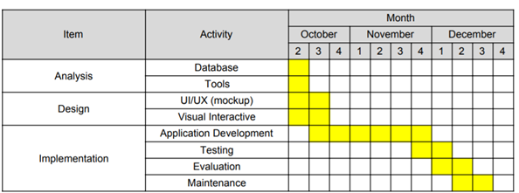

Table 2.1 Project time schedule management

From the above time schedule management, we divide the project progression into three parts (analysis, design and implementation). Analysis section mainly includes how we interpret the interaction across the database and application based on the ERD diagram, including the tools that we are going to use to make the program. This section is estimated to be done in the second week of October.

For the design section, a mockup for website UI/UX with interactive visualization (without each page interaction) inside the application will be worked on along with the analysis part, and is expected to be done in the third week of October.

The implementation section is divided into four parts (application development, testing, evaluation and maintenance), where each part has different time allocation. Application development is the time when we start to work on the application program which consists of two roles, user and administrator. The web application is built based on the diagrams that we have created, in which the web application has seven parts (database, registration (including login and logout), main screen & game mode option, speed typing mode, listening mode, gibberish mode, and statistics). Testing and evaluation parts will be worked on in collaboration with a user, so the user’s feedback will also influence how the application works. After those parts are done, the application is maintained until the agreed time.

## 2.2 Risk Analysis

In the process of developing the application, there will be many unexpected problems and may be able to disturb the progress by creating delays which will affect the plans related to the schedule. To mitigate these problems, we used some platforms which include:

* Trello used as a progress board. We first create a list of things that need to be done, as well as a breakdown of these big tasks. If there is a task that has been completed, then the task will be given a tick on the board from Trello as a sign that the task has been done. Thus, tracking the progress of application development will be easier.
* Discord and Line as the preferred platform for maintaining communication and holding meeting
* Github as the platform to collaborate and develop the website.

## SURAT PERJANJIAN KONTRAK

Perjanjian Kerja Waktu Tertentu pada tanggal 12 Oktober 2021 oleh dan antara:

1. Nama : Hannah Gracia Tiurinda

Jabatan : Pengembang Website

Bertempat di- : Jakarta

Dalam hal ini bertindak sebagai pihak Pengembang Website Master Typing yang selanjutnya disebut sebagai PIHAK PERTAMA.

2. Nama : Arinda Berty

Jabatan : Klien Pengembangan Website

Bertempat di- : Batam

Dalam hal ini bertindak sebagai klien pengembangan website Master Typing yang selanjutnya disebut sebagai PIHAK KEDUA.

PIHAK PERTAMA dan PIHAK KEDUA sepakat untuk mengikatkan diri dalam perjanjian kontrak dengan ketentuan-ketentuan sebagaimana dituangkan dalam pasal-pasal di bawah ini:

**PASAL 1**

**Jangka Waktu Kerja**

1. PIHAK PERTAMA bersedia menerima dan mengerjakan pekerjaan yang diberikan oleh PIHAK KEDUA terhitung efektif selama 2 bulan 1 minggu dari tanggal 15 Oktober 2021 sampai dengan 22 Desember 2021.

2. PIHAK KEDUA selaku pemberi pekerjaan bersedia memberikan data dan informasi yang dibutuhkan guna pengembangan Website selama 2 bulan 1 minggu dari tanggal 15 Oktober 2021 sampai dengan 22 Desember 2021.

**PASAL 2**

**Deskripsi Pekerjaan**

1. Nama Website adalah “Master Typing” yang selanjutnya disebut sebagai “Website Master Typing tersebut”
2. PIHAK PERTAMA yang memiliki tim beranggotakan 3 (tiga) orang yang bertugas untuk mengembangkan Website tersebut dengan rincian pekerjaan sebagai berikut:
3. Menyediakan desain antarmuka Website tersebut, yang sesuai dengan kebutuhan dan kesepakatan bersama antara KEDUA BELAH PIHAK.
4. PIHAK PERTAMA akan memberikan masukan-masukan terkait proses pengembangan dan penerbitan Website Master Typing kepada PIHAK KEDUA, agar proses tersebut dapat berjalan dengan baik dan benar.
5. PIHAK PERTAMA bersedia mengembangkan Website Master Typing tersebut dengan fitur-fitur sebagai berikut:

I. Fitur Speed Typing

II. Fitur Listening

III. Fitur Gibberish

IV. Fitur Pemilihan Bahasa

1. PIHAK PERTAMA memiliki fase-fase pengembangan Website Master Typing tersebut sebagai berikut:
2. Analisis Kebutuhan, yaitu pengumpulan Data dan Informasi terkait pengembangan website kemudian diubah menjadi poin-poin tugas-tugas yang wajib dilaksanakan oleh PIHAK PERTAMA.

Pada tahap ini PIHAK PERTAMA akan menanyakan dan meminta PIHAK KEDUA mengenai segala informasi terkait pengembangan website, baik itu informasi secara verbal maupun tertulis.

1. Pemodelan sistem (flowchart) dan Desain Antarmuka Website.

PIHAK PERTAMA akan menggunakan segala Kebutuhan yang telah dirumuskan pada tahap Analisis Kebutuhan (poin a) menjadi rancangan desain antarmuka Website.

PIHAK KEDUA wajib memberikan masukan terkait setiap proses desain yang dikerjakan oleh PIHAK PERTAMA maksimal 10 hari setelah PIHAK PERTAMA telah melaporkan kepada PIHAK KEDUA. Hal ini dilakukan agar PIHAK PERTAMA tidak menunggu terlalu lama masukan-masukan yang diberikan oleh PIHAK KEDUA, karena hal tersebut dapat mengganggu jadwal pelaksanaan pengembangan Website tersebut.

1. Implementasi setiap desain-desain pada poin b menjadi sebuah kode sumber (source code).

PIHAK PERTAMA menulis kode-kode program sehingga website tersebut dapat digunakan sebagaimana mestinya.

PIHAK KEDUA wajib memberikan masukan setiap selesai menguji coba website tersebut, untuk kemudian ditindaklanjuti PIHAK PERTAMA sehingga menghasilkan website yang diharapkan dan sesuai dengan kebutuhan yang telah disepakati kedua belah pihak.

PIHAK PERTAMA wajib mencatat setiap masukan-masukan PIHAK KEDUA agar nantinya dapat dilaksanakan perbaikan-perbaikan website setelah tahap implementasi telah dilakukan.

1. Pengujian Website. Menguji setiap komponen website, baik komponen desain, fungsionalitas, validasi input dan output, dan lain-lain agar website sesuai dengan apa yang dibutuhkan.

PIHAK PERTAMA wajib menguji website yang telah dibuat bersama-sama dengan PIHAK KEDUA. Setiap hasil pengujian, berupa laporan masalah (bugs ataupun error) website, wajib dicatat di dokumen tertulis sehingga dapat dipantau bersama antara kedua belah pihak. Setiap laporan masalah wajib diselesaikan oleh PIHAK PERTAMA dalam waktu tertentu, atau selama masa Pengujian berlangsung.

PIHAK KEDUA berhak memberikan masukkan-masukkan terkait prioritas perbaikan masalah.

**PASAL 3**

**Pelaksanaan Tugas**

1. PIHAK PERTAMA wajib menjalankan tugas dengan baik dan memenuhi target pengembangan Website Master Typing tersebut yang telah ditentukan oleh PIHAK KEDUA yang tertera di Pasal 2 Poin Nomor 1.
2. PIHAK PERTAMA wajib memberi pemberitahuan kepada PIHAK KEDUA terkait adanya setiap perubahan atau penambahan fitur pada website.
3. PIHAK KEDUA berhak memberikan pengarahan mengenai Pengembangan Website yang sesuai dengan kebutuhan PIHAK KEDUA.
4. PIHAK PERTAMA berhak memberikan masukan-masukan mengenai Pengembangan Website.

**PASAL 4**

**Pengupahan**

1. PIHAK KEDUA tidak mengeluarkan uang sebesar apapun kepada PIHAK PERTAMA.
2. Apabila PIHAK PERTAMA telah menyelesaikan tugasnya, kepemilikan atas website tersebut akan menjadi milik dari PIHAK PERTAMA.

**PASAL 5**

**Waktu Kerja**

1. Waktu kerja PIHAK PERTAMA adalah 2 bulan 1 minggu, dan sesuai dengan hari dan jam kerja yang berlaku di Indonesia.
2. Dalam kondisi tertentu PIHAK KEDUA dan PIHAK PERTAMA dapat menambahkan kesepakatan di waktu tertentu untuk pertemuan atau rapat guna membahas masalah-masalah yang terjadi di dalam pengembangan Website Master Typing tersebut tanpa keluar dari lingkup pekerjaan yang telah disepakati bersama dan sesuai dengan Pasal 2 dan Pasal 3.
3. PIHAK KEDUA bersedia dihubungi secara online apabila PIHAK PERTAMA membutuhkan untuk meminta data terkait pengembangan Website Master Typing yang sudah disepakati bersama sesuai dengan Pasal 1 dan Pasal 3.

**PASAL 6**

**Batasan Pekerjaan**

1. Pekerjaan yang dilakukan oleh PIHAK PERTAMA hanya terbatas pada jasa pengembangan website Master Typing tersebut.
2. PIHAK KEDUA tidak memberikan informasi ataupun data apapun diluar pengembangan website Master Typing tersebut dan berkewajiban memberikan alasan kepada PIHAK PERTAMA agar dipahami bersama.
3. PIHAK PERTAMA akan memberikan source code dan aset desain antarmuka website kepada PIHAK KEDUA ketika kontrak kerja berakhir ke dalam bentuk file digital yang dikirimkan melalui email yang telah disepakati bersama.
4. PIHAK PERTAMA berhak menolak suatu pekerjaan di luar lingkup pekerjaan yang telah disepakati bersama.

1. Apabila PIHAK KEDUA menyatakan tambahan Pekerjaan di luar kesepakatan Kontrak Kerja ini, wajib dibahas setelah kesepakatan yang telah berjalan berakhir.
2. PIHAK PERTAMA berkewajiban memperbaiki masalah (bug ataupun error) di website yang dilaporkan PIHAK KEDUA.
3. PIHAK KEDUA berkewajiban melaporkan masalah (bug ataupun error) di website dengan informasi yang jelas, yaitu informasi merek Laptop yang digunakan, versi OS dan waktu kejadian masalah (misal pukul 10 pagi).
4. Adapun apabila PIHAK KEDUA melaporkan masalah dan meminta mengganti atau mengubah (menambah ataupun mengurangi) fitur tersebut, maka dinyatakan sebagai tambahan Pekerjaan.
5. Perbaikan masalah oleh PIHAK PERTAMA yang dimaksud adalah agar fitur tersebut dapat berjalan dengan baik oleh pengguna Website, tanpa hambatan ataupun gangguan maupun crash.
6. PIHAK PERTAMA bersedia me-monitoring pekerjaan, melakukan perawatan (maintenance) website yang telah dikembangkan sebagai masa garansi selama jangka waktu 15 hari setelah proses Pengembangan selesai.

**PASAL 7**

**Berakhirnya Perjanjian Kerja**

1. PIHAK PERTAMA dan PIHAK KEDUA sepakat untuk mengakhiri Perjanjian Kerja dengan alasan dan atau keadaan sebagai berikut:
2. PIHAK PERTAMA telah melaksanakan tugasnya sesuai dengan lingkup pekerjaan yang telah disepakati.
3. PIHAK PERTAMA tidak melaksanakan tugasnya sampai dengan waktu pekerjaan berakhir.
4. PIHAK PERTAMA atau PIHAK KEDUA melanggar aturan yang telah tercantum di Surat Perjanjian Kontrak ini.

**PASAL 8**

**Perselisihan**

1. Semua bentuk perselisihan antara PIHAK PERTAMA dan PIHAK KEDUA akan diselesaikan secara kekeluargaan dan dengan cara musyawarah mufakat.

1. Jika tidak terdapat kesepakatan dalam penyelesaian perselisihan antara PIHAK PERTAMA dan PIHAK KEDUA, maka kedua belah pihak sepakat untuk meminta bantuan kepada LPPHI (Lembaga Penyelesaian Perselisihan Hubungan Industrial) untuk mencari penyelesaiannya.

**PASAL 9**

**Penandatanganan**

1. Surat Perjanjian ini ditandatangani dalam keadaan sadar oleh kedua belah pihak, tanpa paksaan dari pihak manapun.
2. Surat Perjanjian ini dibuat rangkap 2 (dua), yaitu 1 (satu) rangkap untuk PIHAK PERTAMA dan 1 (satu) rangkap untuk PIHAK KEDUA, yang masing-masing memiliki kekuatan hukum yang sama.
3. Dengan ditandatanganinya Surat Perjanjian Kontrak ini, maka kedua belah pihak sepakat untuk melaksanakan ketentuan-ketentuan dalam perjanjian kontrak ini dengan demikian kedua belah pihak terikat demi hukum dalam suatu hubungan kerjasama.

Perjanjian ini dibuat dengan sebenarnya tanpa paksaan dari pihak manapun, masing-masing pihak juga dalma keadaan sehat jasmani dan rohani. Perjanjian kerja ini dibuat rangkap 2 (dua), masing-masing mempunyai kekuatan hukum yang sama.

Demikian Perjanjian Kontrak ini dibuat oleh PIHAK PERTAMA dan PIHAK KEDUA dalam keadaan sehat dan sadar, tanpa pengaruh ataupun paksaan dari pihak manapun.

Pihak Pertama, Pihak Kedua,

Pengembang Website Klien Pengembang Website

 

Hannah Gracia Tiurinda Arinda Berty

# 

# CHAPTER III

# UNIFIED MODELING LANGUAGE AND DESIGN

This chapter is a description and picture for Master Typing website development project management. UML that consist of Activity Diagram, Use Case Diagram, Sequence Diagram, and Collaboration Diagram, also the Design consist of User Interface of the website are all included in this unified modelling language and design chapter.

## 3.1 UML Diagrams

This subchapter consists of four diagrams which illustrate how the interactions across the Master Typing application take place. Each diagram will depict different point of view within the application so that the interactions will be clearer and detailed.

**3.1.1 Activity Diagram**

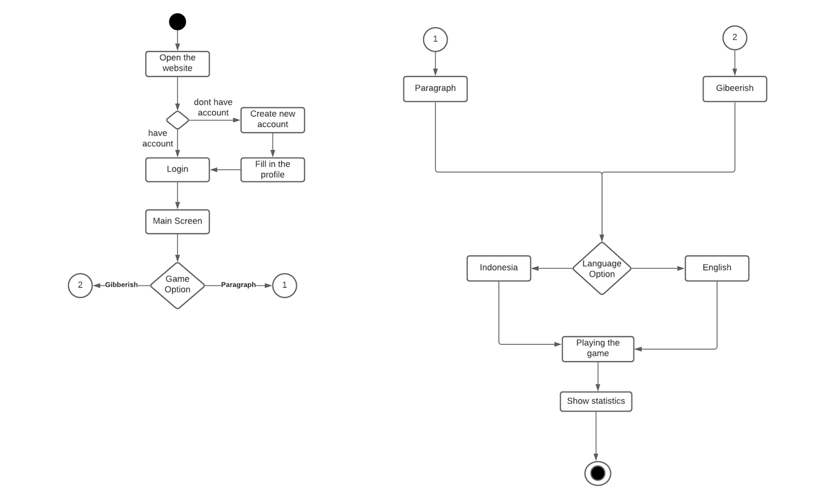

Fig. 3.1 Activity Diagram

The activity diagram is a behavioral diagram in the UML diagram. The function of the activity diagram is to describe the dynamic aspects of the system. This diagram explains the sequence of processes from the running of the master typing program. The process or initial stage of this program, where the user accesses or opens the program’s website. The next thing that the user can do after accessing the website is that the user must first log in. If the user doesn’t have an account, the user must create an account. On the main screen, the user will be given a choice of games, such as paragraph, gibberish, and listening. And then the user will be given a choice of languages. After playing the game, the user will be shown statistics of the game.

**3.1.2 Use Case Diagram**

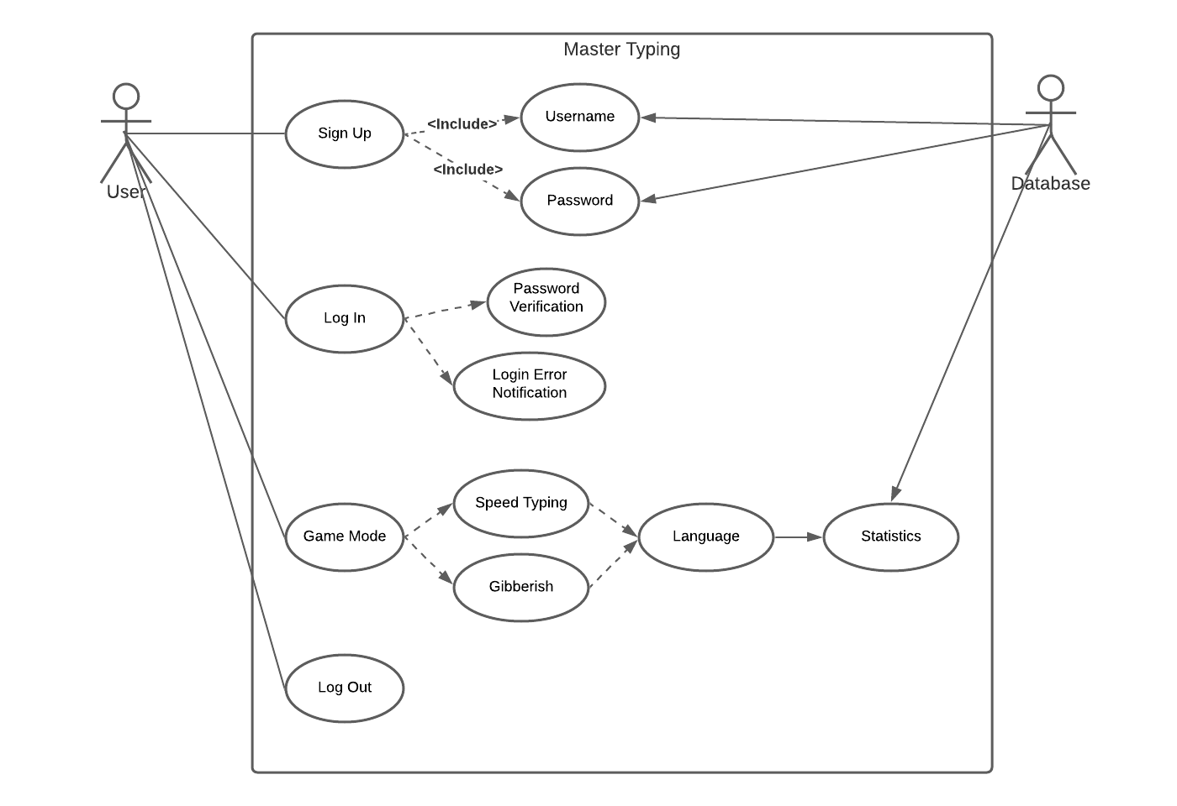

Fig. 3.2 Use Case Diagram

The use case diagram is a UML primary form of system software that specifies the behavior of the software program. In this use case diagram, there are two subjects that take part in this master typing project program, namely user and admin or database. Based on the diagram, the things that users can do, such as sign up for an account, login account, play the game, and log out. And the things that admin or database can do, such as save or see information about user account and statistics of the games.

**3.1.3 Sequence Diagram**

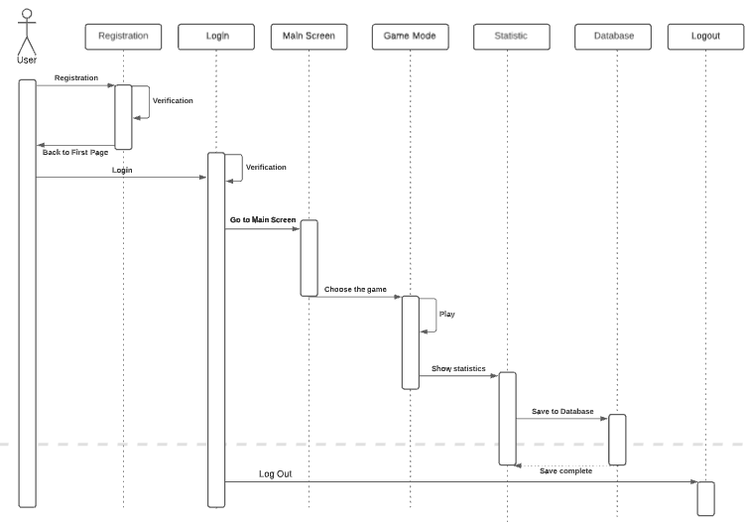

Fig. 3.3 Sequence Diagram

A sequence diagram is a diagram that shows interactions between objects in application or system. The first sequence diagram shows a scenario between Master Typing website and its user when they don’t have an existing account and want to create it. The user would register the application, which will bring them to the registration page. After the user fills in the registration and does the verification, the account is created and can log in to the application using their newly created account. Next sequence is, the user needs to choose the game that he/she would like to play. The game that the user played will be displayed statistically once the user is done, where its statistics are saved in the database. The user can end their session by logging out from the application

**3.1.4 Collaboration Diagram**

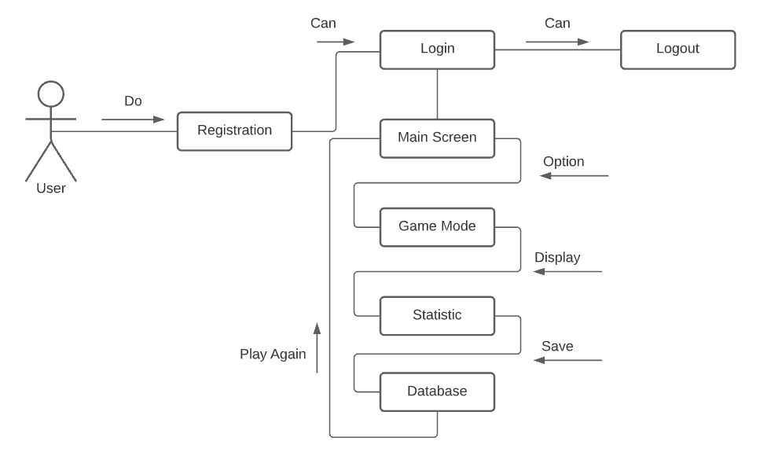

Fig. 3.4 Collaboration Diagram

Collaboration diagram shown above depicts how each page and entity communicate with one another to create a more detailed version of their roles. This diagram follows a certain flow of events whenever they perform a use case, so that the information can be extracted to determine each entity’s responsibility. From the diagram above, users are first brought into the registration page to do the registration process. After it’s done, users can do the login process with their previously registered username and password, so that they can get into the main screen and start the game. There are three options that the users can choose from, and at the end of the game, game statistics are displayed, followed by a writing process to the database to save the latest users’ statistics. Finally, the users are brought back to the main screen to either play the game again, or do the logout process and exit the application.

## 3.2 Database Diagram

This subchapter will explain the ERD diagram and UML diagram for the database that will be used in this master typing project. This database will be used to create a master typing project, especially in creating player accounts and player game statistics.

**3.2.1 ERD Diagram**

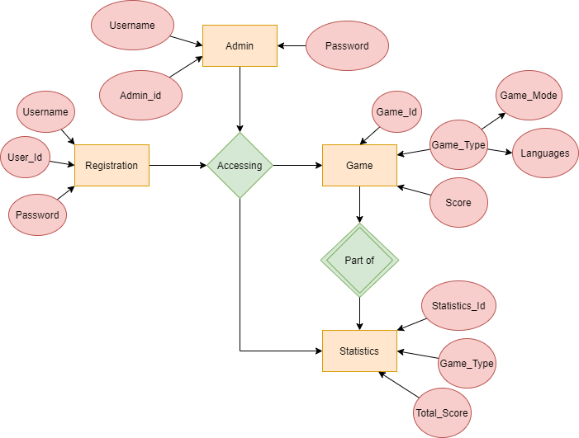

Fig. 3.5 ERD Diagram

The picture above is a form of ERD diagram database that will be used in this master typing project. Registration entity is the entity in creating the Registration table in the master typing database. Registration entity has a function to save data user accounts in the registration table database. Registration entity has attributes such as User_Id, Username, and Password. The second entity is Admin entity, this entity has attributes such as Admin_Id, Username, and Password. This two entities can accessing two another entities such as Game entity, and Statistics entity. Game entity has a function to save game data in the Game table database. Game entity has attributes such as Game_Id, Game_type, and Score. And the last entity is Statistics entity,game entity is a part of this entity. Statistics entity has a function to calculate score and statistics in all games that have been played with user and save the data. Statistics entity has attributes such as Statistics_Id, Game_Type, and Total_Score.

**3.2.2 UML Diagram**

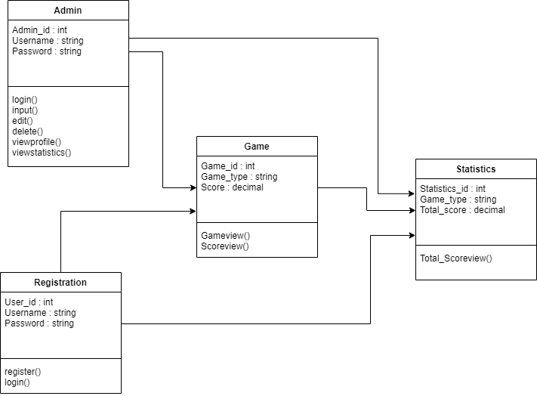

Fig. 3.6 UML Diagram

The picture above is a form of UML diagram database that will be used in this master typing project. In the Registration entity, User_Id has an integer data type, for Username and Password have a string data type. In the Admin entity, Admin_Id has an integer data type, for Username and Password have a string data type. In the Game entity, Game_Id has an integer data type, for Game_Type has a string data type, for Score has a decimal data type. In the Statistics entity, Statistics_Id has an integer data type, for Game_type has a string data type, for Total_score has a decimal data type.

# 

# CHAPTER IV

# Implementation

This chapter will explain the implementation that has been used in this project. The things described in this implementation chapter only discuss methods, algorithms, and programs in making the game modules such as Speed Typing game which is divided into two games, namely in English and Bahasa also modules Gibberish game.

The following picture is a snippet of the program code used in making the speed typing game and also the gibberish game in php and also javascript.

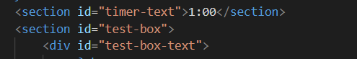

Fig. 4.1 Timer and box

The first function is timer-text function, this function is to display the timer and perform a countdown to indicate that the game has started and the game will stop when the timer runs out. The next function is the test-box function, this function is to make a text box so the box can display words in the text box.

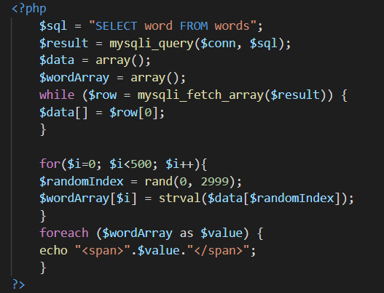

Fig 4.2 Retrieve words from database

The code snippet above is a function in the Speed Typing game in English to retrieve words from the database which will later be displayed in the text-box as a question. The data of these words will be converted into an array form and the array will be looped so that it will generate random words to be displayed. And last is a function to make each word into a single “span” which will later be useful for checking the typed answer whether the input is correct or not. For the Speed Typing game in Bahasa and gibberish game, the difference is the name of the table of words used and the size of the array that adjusts to the number of columns in the table of words used.

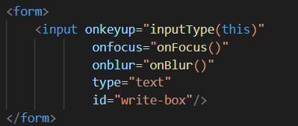

Fig 4.3 Input box

The code snippet above is a function to create a box where the user can input the answer. The code has some parameters like onkeyup for inputType and the type is text, onfocus and on blur.

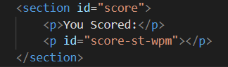

Fig 4.4 Score

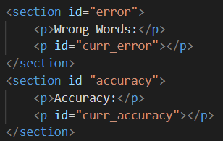

Fig 4.5 Error and accuracy

The code snippet above is a function to display scores like WPM or words per minute, wrong words, and also accuracy.

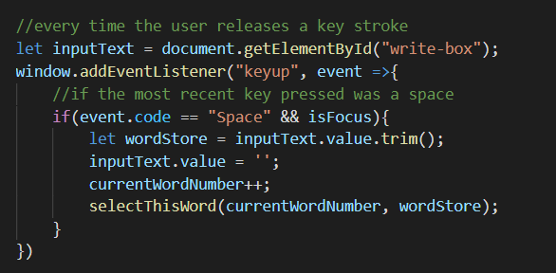

Fig 4.6 Keystroke Function

The code snippet above is a function when the user is done inputting answer and pressing the “Space” button. The answer will be saved and checked whether the answer is right or wrong in the function in the image below. When user presses the “Space” button, the input answer in the answer-box will be removed. When the answer is right then words in the text-box will turn to green and if it’s false, they will turn red.

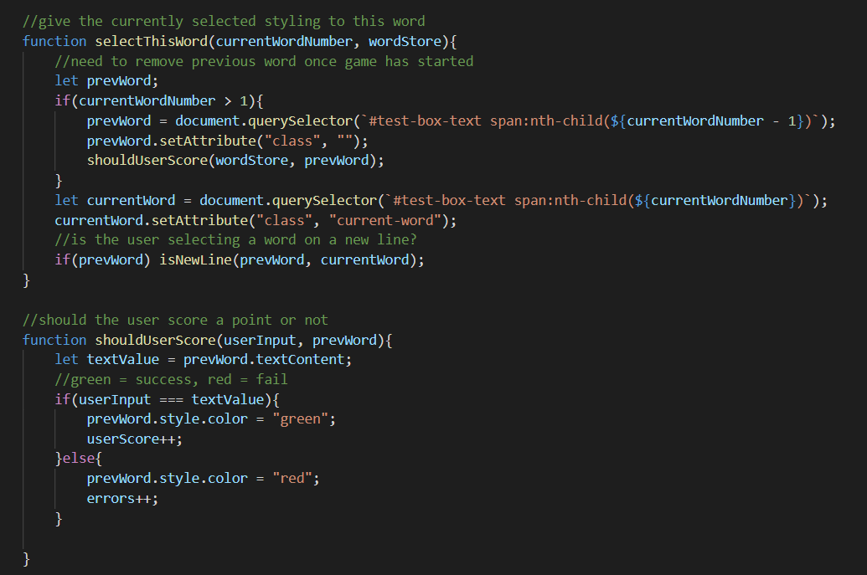

Fig 4.7 Span and text color

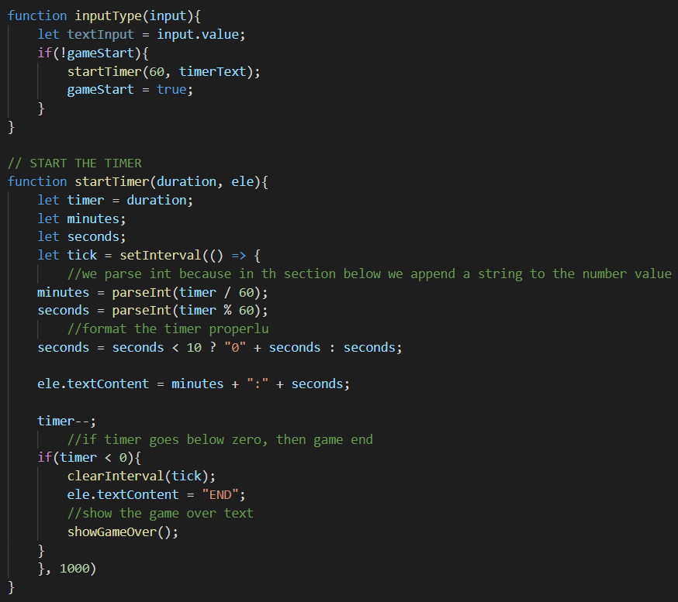

Fig 4.8 InputType function

The function in the code snippet above is the inputType function where the function is to put the user’s answer and declare the timer value and if the user’s start the game then the timer will start the countdown. The startTimer function which functions to parameterize the shape of the timer so that it takes the form of 1:00. The startTimer function also declares an algorithm so that the countdown calculation corresponds to real time. After the countdown becomes zero which means the time is up, then the function will move to the showGameOver function.

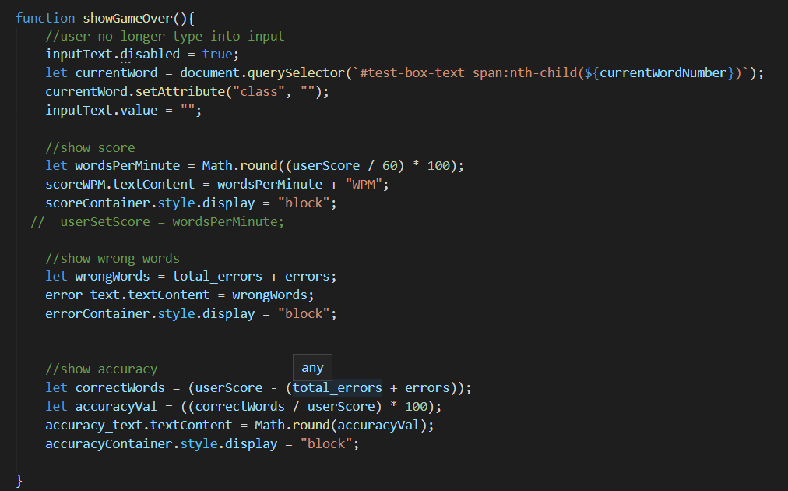

Fig 4.9 Display function

The code snippet above is a function to display score and statistics such as WPM or words per minute, wrong words and also accuracy. Each score uses an algorithm so the results match the calculations. For calculating the WPM, using calculation userScore divided by sixty and the result will be multiplied by one hundred. For calculating the wrong words, the program uses the sum of total_errors and errors. For calculating the accuracy, using calculation correctWords divided by userScore and the result will multiply by one hundred. Math.round in the calculation is to return the value of a number rounded to the nearest integer.

The following is the user interface of the master typing website

* Main Interface

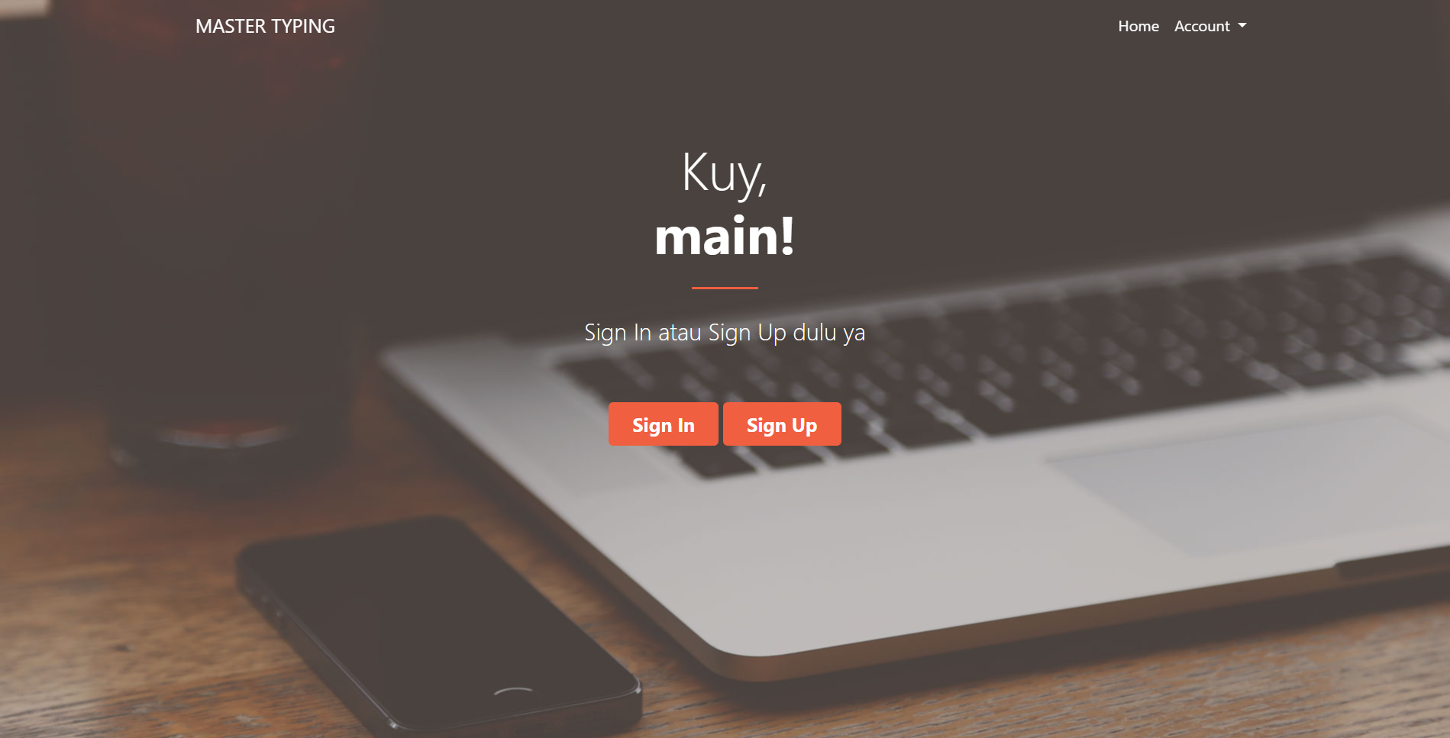

Fig 4.10 Main interface

* Sign Up Interface

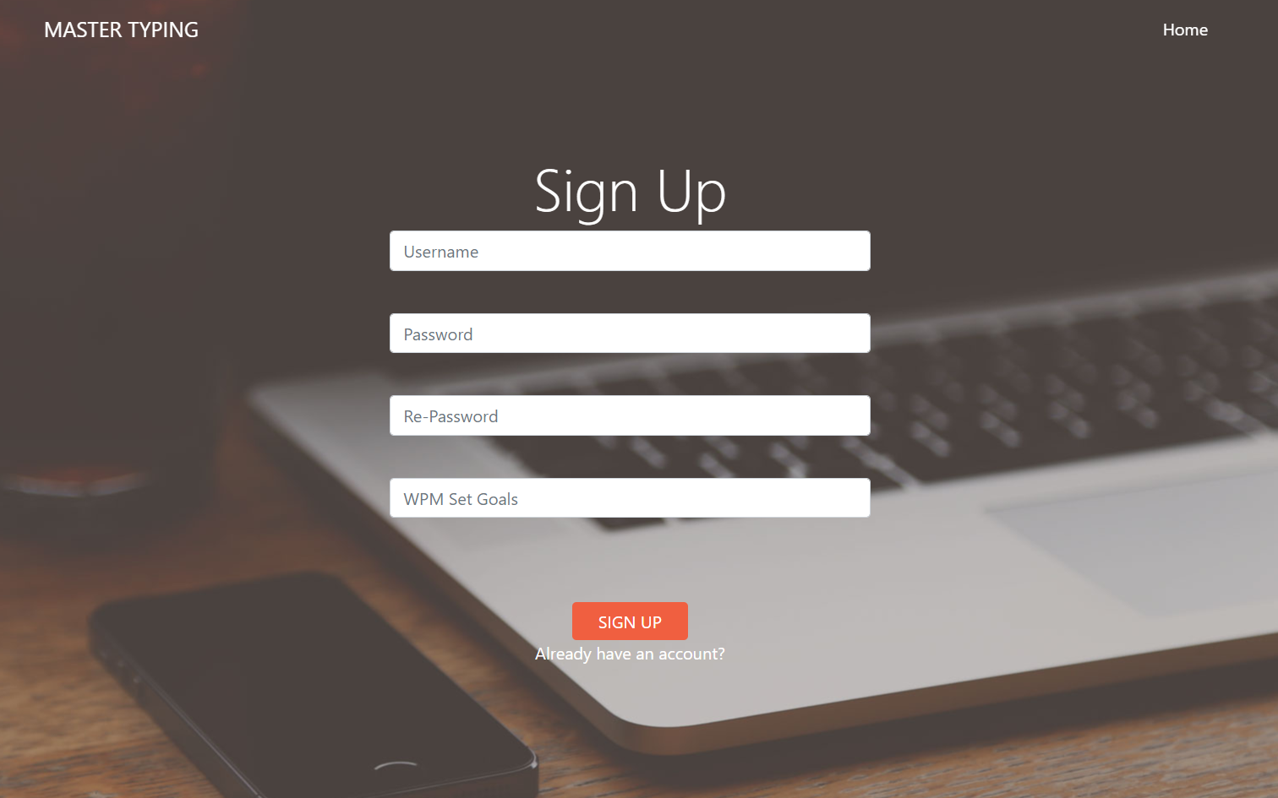

Fig 4.11 Sign up interface

* Sign In Interface

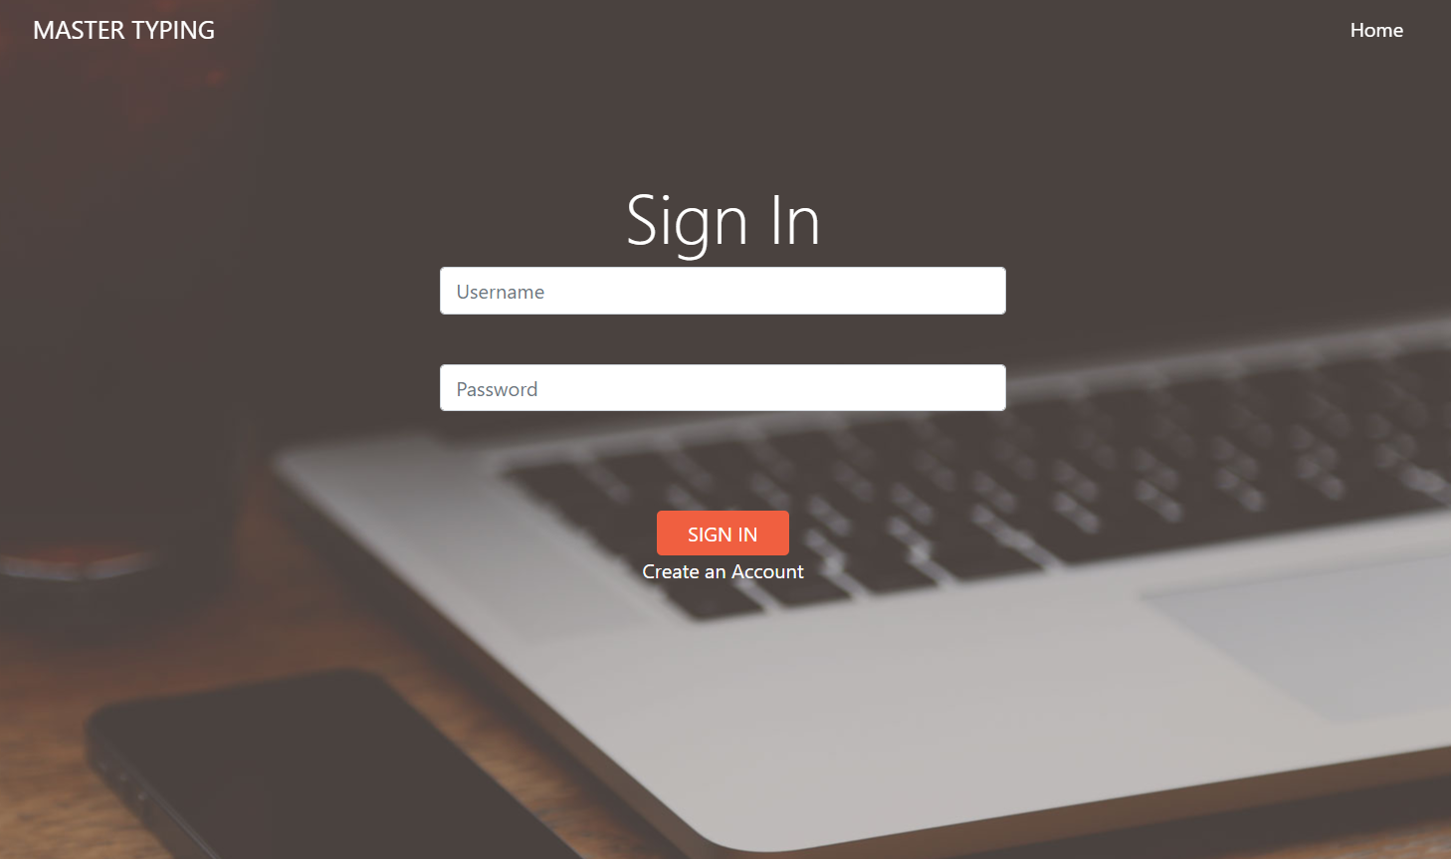

Fig 4.12 Sign in interface

* Lobby-Games Interface

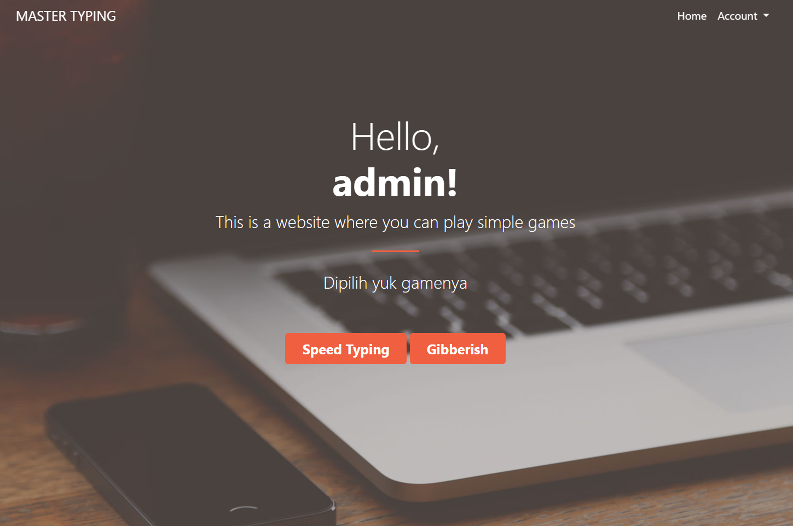

Fig 4.13 Lobby-games interface

* Lobby-Language Interface

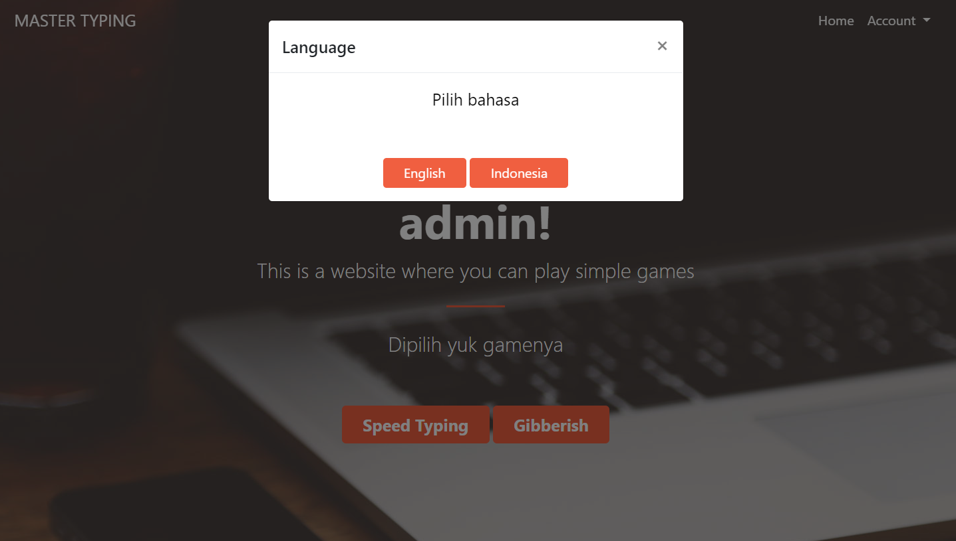

Fig 4.14 Lobby-language interface

* Speed Typing-Game Interface

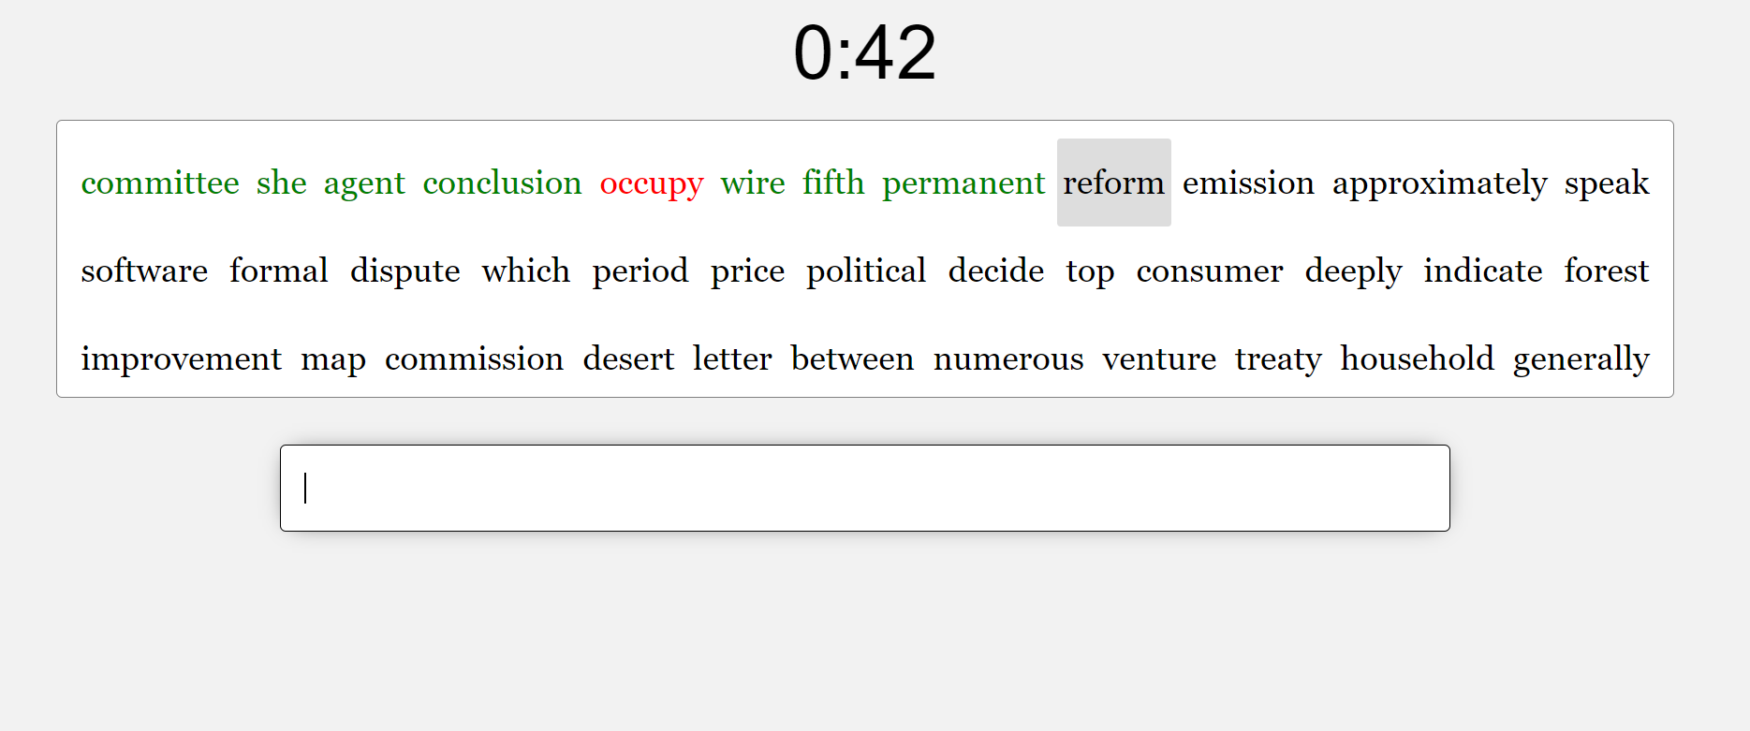

Fig 4.15 Speed typing-game interface

* Gibberish-Game Interface

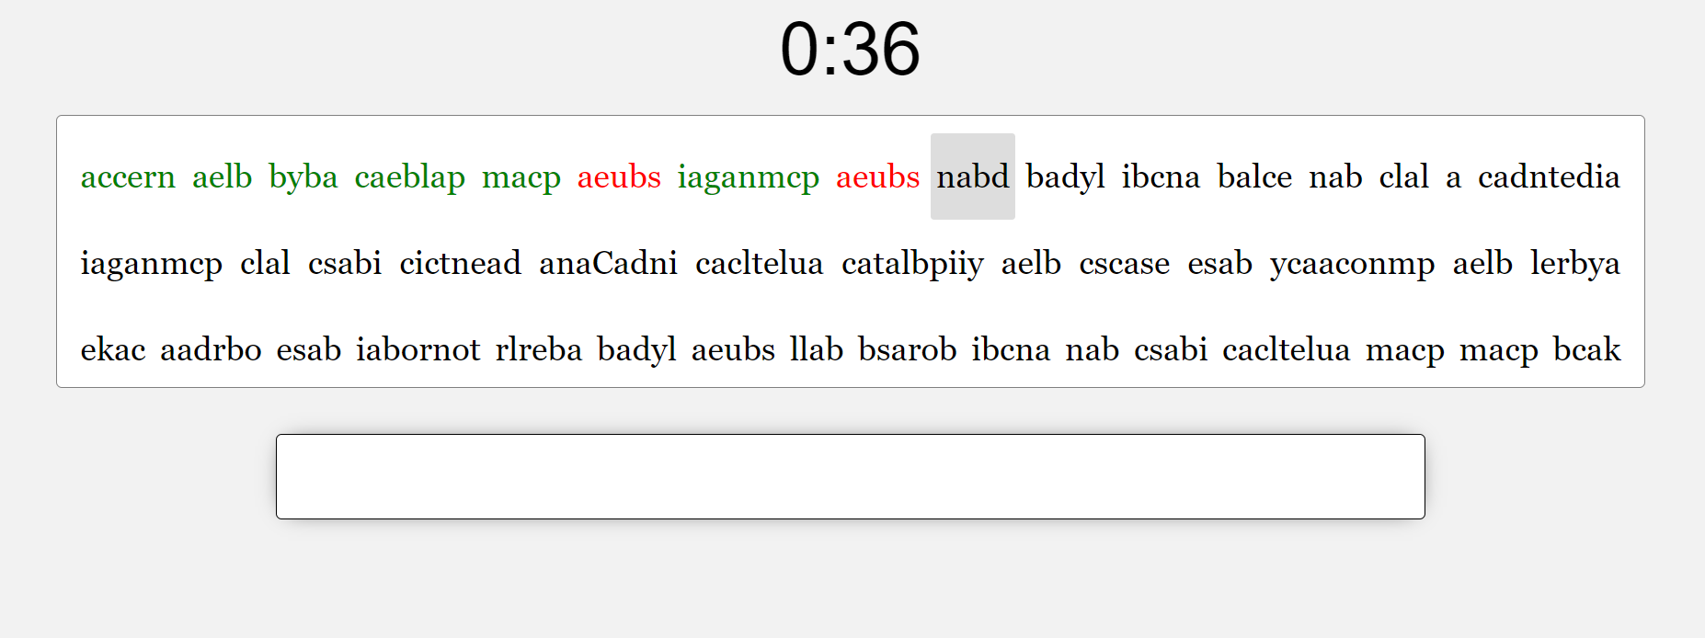

Fig 4.16 Gibberish-game interface

* Result interface

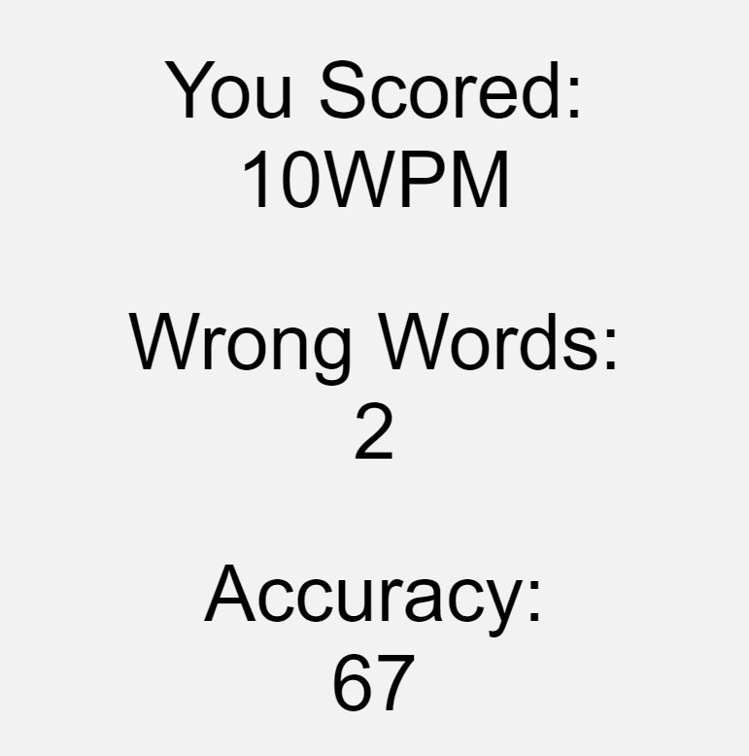

Fig 4.17 Result interface

# CHAPTER V

# Unit Testing

## Software Test Plan

As one of the stages of the Software Development Cycle, while developing the software, it is required to do test units and system integration continuously in order to build a robust, scalable, and less-bug software. Thus, to accomplish that, our team made a test plan as a first step to start this phase.

This test plan is a part of test documentation for ‘Master Typing’ website. In general, the document is detailing the objectives, tasks, tactics, and testing report. And as the main purpose of this document, both the unit test and system integration are reported in a table form.

## Objectives

This document describes the plan for testing the prototype of the ‘Master Typing’ website. ‘Master Typing’ website is developed using PHP and JavaScript languages. This test plan document supports the following objectives:

* Identify existing project information and aspects of the website that should be tested
* List the recommended test requirements
* Describe the testing strategies to be employed
* Identify the required resources

These are the members of Group 8 with their respective roles:

| Name | Role |
| --- | --- |
| Hannah Gracia | Test Engineer |
| Lazaruslie Karsono | Test Engineer |
| Salma Shafira | Test Lead |

Table 5.1 Objectives

Here are the list of our test metrics:

* Total number of test cases
* Number of test cases passed
* Number of test cases failed
* Number of defects found
* Number of critical defects
* Passed test case percentage
* Failed test case percentage
* Fixed defects percentage

Furthermore, the parameters for stopping the testing are as follow:

* Unit tests are not good enough
* Low quality of code
* Meet requested tests coverage
* All test cases are tested and passed

## Tasks

This is the general list of all the modules that has been broken down into several function in unit test:

| Module Name | Roles | Description |
| --- | --- | --- |
| Sign Up Account | User | Users or players must have an account before accessing the whole game |
| Login to an Account | User | Users enter username and password correctly to be able to access the website |
| Choose game and language option to play | User | Users can see several types of games to be played and choose the language |
| Enter the game: Speed Typing | User | Users can play and input text based on the screen with timer calculation |
| Enter the game: Gibberish | User | Users can play and guess the input text based on the word that have been gibberish with time calculation |
| Change password | User | Users are allowed to change their password |
| Leaderboard | User | Users can see their game leaderboard |

Table 5.2 Task

## Tactics

The method to test all the units that have been listed above is manual testing. The team member who built the modules is the first one who tested the functionality and the interface. Then, the module is handed to another team member to be tested again with its own parameter.

Every module has the estimation effort for about:

| Task | Estimate Effort |
| --- | --- |
| Create the test parameter | 1 hour |
| Test the modules | 2 hours |
| Build test report | 2 hours |
| TOTAL | 5 hours |

Table 5.3 Tactics

A set of tactics useful in unit testing is intended as a comprehensive list of tactical approaches to Software Quality Assurance. The tactic is to use gray-box testing approaches. With gray-box testing, the tester should know internal data structure and algorithm to execute the test. This unit test requires a backend data repository such as a database to determine the output of the value.

## Test Coverages

Below are the list of things that need to be tested before the ‘Master Typing’ website is considered fully functional:

1. Data and Database Integrity Testing
2. Verify credential authentication to the database
3. Verify access to the ‘Master Typing’ dashboard
4. Verify correct retrieval of update of database data
5. User Interface Testing
6. Verify ease of navigation through a set of screens
7. Verify the responsiveness when used on various screen sizes
8. Performance Testing
9. Verify response time for authentication
10. Verify response time for the game
11. Verify response time for changing password

## Test Methods

| Testing Type | Requirement | Method |
| --- | --- | --- |
| Data and Database Integrity | Verify credential authentication to the database | Log in using existing accounts or register a new one |
| Verify access to the ‘Master Typing’ dashboard |
| Verify correct retrieval of update of database data |
| User Interface | Verify ease of navigation through a set of screens | Use the website and review the ease of using the website with internal team and client |
| Verify the responsiveness when used on various screen sizes | Use the website on at least three different screen sizes |
| Performance | Verify response time for authentication | Log in to the application |
| Verify response time for the game | Access all of the game in the website |
| Verify response time for changing password | Change password account at least five times |

Table 5.4 Test Methods

## Test Responsibilities

Our team is planning to have two main parties involved to perform the test methods for the application, which is as follows:

* Our client, and
* Our team members

Our team is also planning to have a third party involved to perform the test methods, which consists of our team members’ friends, as volunteers. All parties will be responsible to collect information, such as irregularities or errors in the application or its features, to help our team members in fixing and maintaining the problems that may arise while testing the website.

## Test Plan Types

Our team is planning to perform the whole unit test after each of the features of the application are programmed. In addition, our team also requests to help our team’s client to perform the unit test after all the features of the website are programmed. The testing method that our team used is manual testing method, where the testing is manually performed by the tester.

The test plan types that applied in this unit test are using Level-specific test plans. Things to consider when testing with a level-specific test plan is, the unit of each task module, system of the task module, and also the acceptance test plans.

## Testing Strategy

After each of the main features of the application is programmed, our team members will test the website. Any irregularities or errors that the team members found in the website will be fixed before moving to program the next feature of the application. The client will then be given a questionnaire to fill about the general experience while testing the website. Data collected from this questionnaire will be evaluated and analyzed by our team members, to fix any undiscovered errors or to improve the website.

## Unit Testing

|  | **Project Name:** | **Master Typing** | **Test Designed by:** | **Group 8** |
| --- | --- | --- | --- | --- |
| **Project Code:** | 1 | **Test Designed date:** | 15/11/2021 |
| Document Code: | Test Plan | **Test Executed by:** | Group 8 |
| Notes | Speed Typing unit test | **Test Execution date:** | 21/11/2021 |

| No | Function Code | Description | Passed | Failed | Status |
| --- | --- | --- | --- | --- | --- |
| 1 | homePage | Dashboard or screen to start the website | Pass | - | Homepage website can be accessed |
| 2 | Register | Create an account by inserting username and password | Pass | - | Account can be register |
| 3 | Login | Login an account by inserting username and password | Pass | - | Account can be logged in |
| 4 | boxSoal | Widget to show the question | Pass | - | Words in the question box can be displayed |
| 5 | boxJawaban | A controller to react with the space button | Pass | - | User can input the answer and using space button to execute the input |
| 6 | timerSoal | Widget to show the timer calculation | Pass | - | Timer can be displayed and counted down |
| 7 | changePassword | Create or change new password by choosing change password option | Pass | - | Password can be changed |
| 8 | Logout | Logout account by choosing Logout option | Pass | - | Account can be logged out |

Table 5.5 Unit Testing

## System and Integration Testing

| Goals | Description | Status | Reason |
| --- | --- | --- | --- |
| Finish the website | The website is ready to deploy | On process | Website is not finished |
| Start run of Test Plan I | Run unit testing plan I | Complete | The separate module has been combined |

Table 5.6 System and Integration Testing

## Questionnaire Result

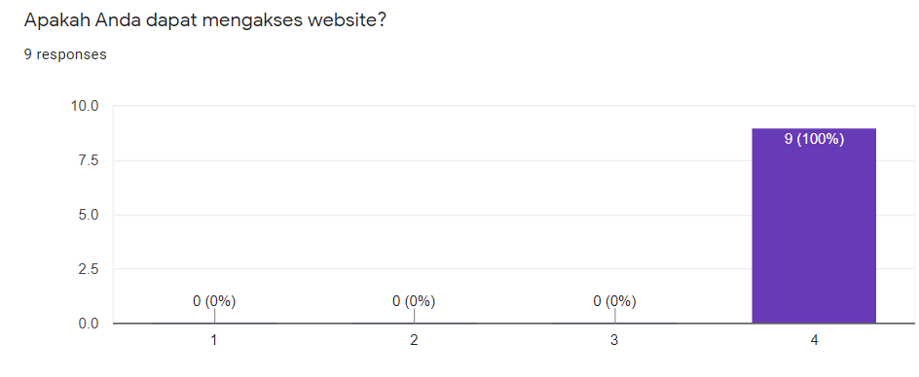

Fig 5.1 Result 1

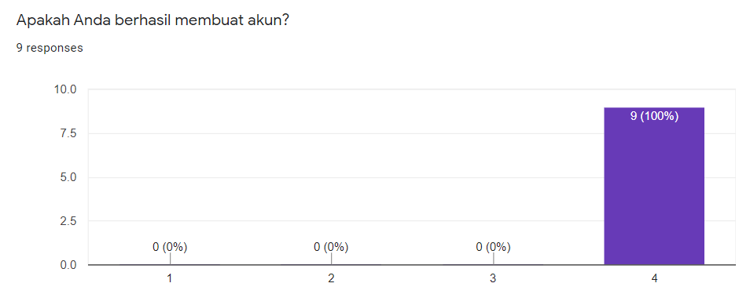

Fig 5.2 Result 2

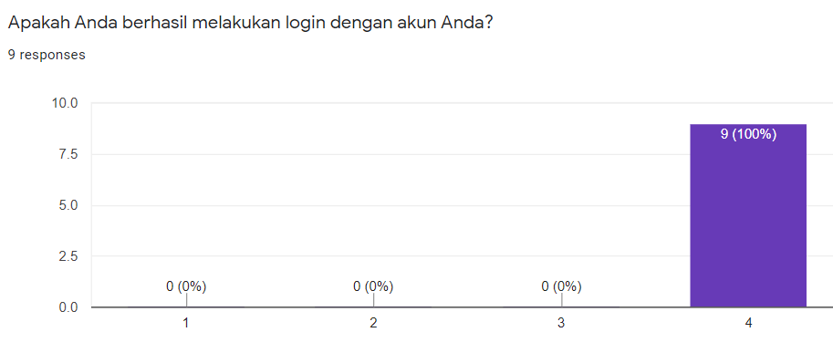

Fig 5.3 Result 3

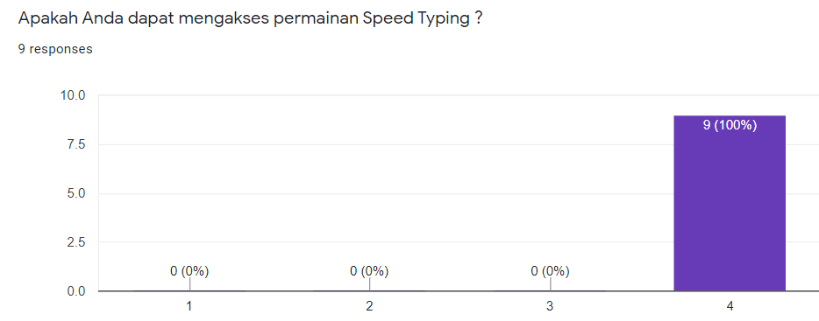

Fig 5.4 Result 4

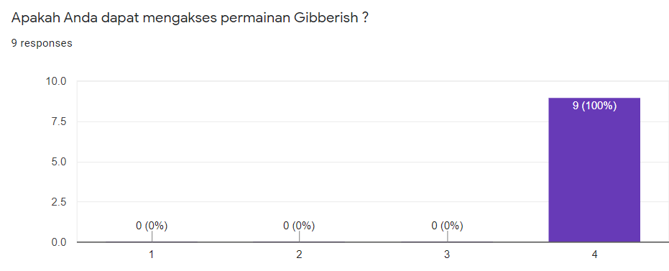

Fig 5.5 Result 5

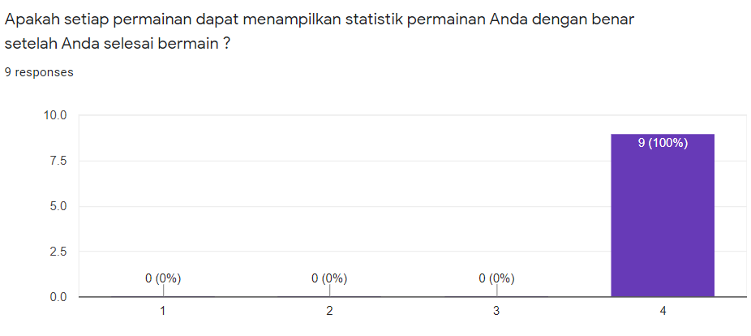

Fig 5.6 Result 6

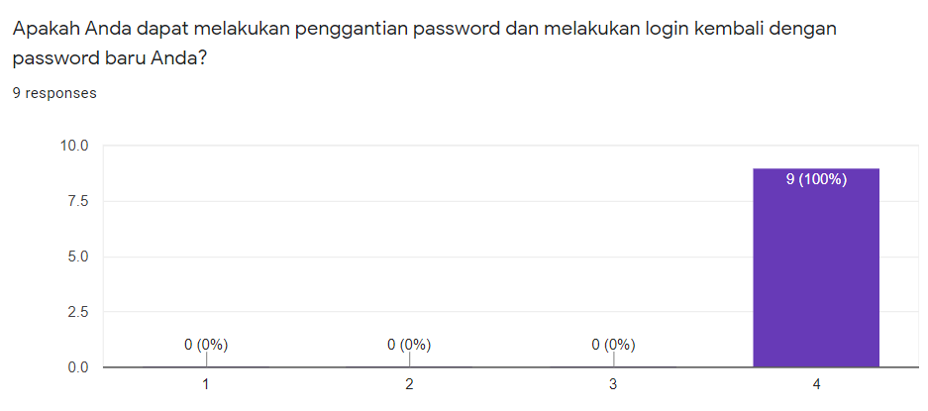

Fig 5.7 Result 7

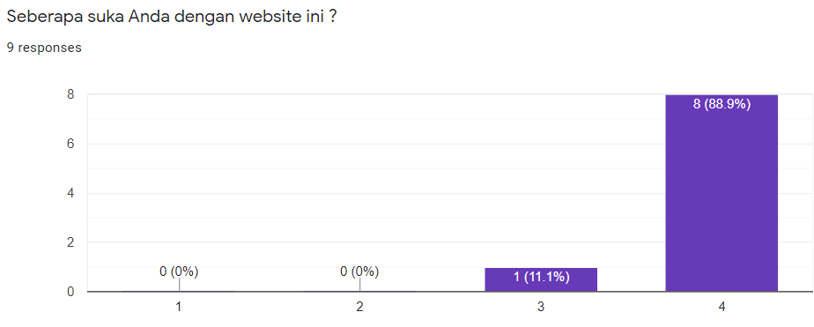

Fig 5.8 Result 8

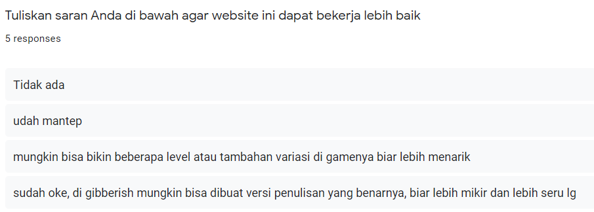

Fig 5.9 Result 9

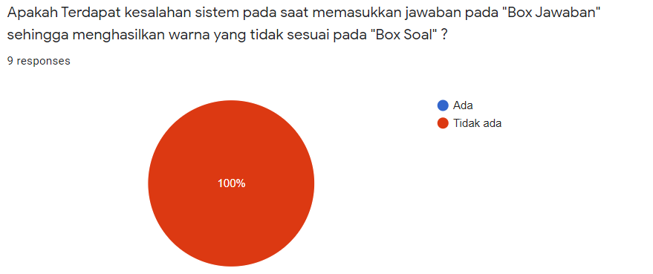

Fig 5.10 Result 10

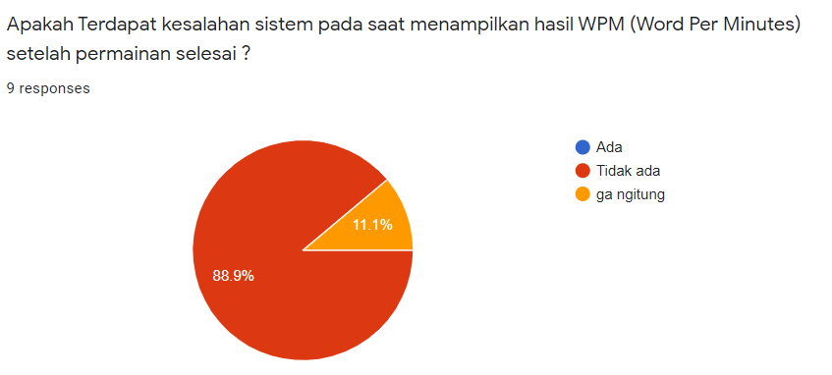

Fig 5.11 Result 11

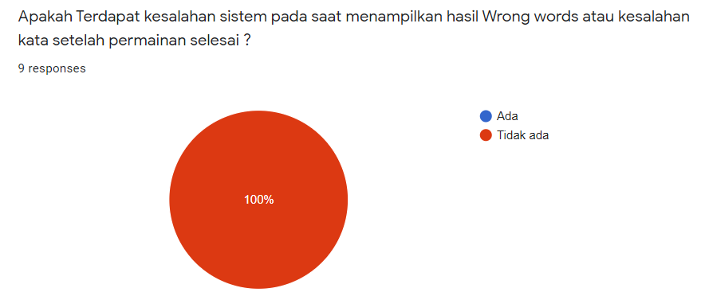

Fig 5.12 Result 12

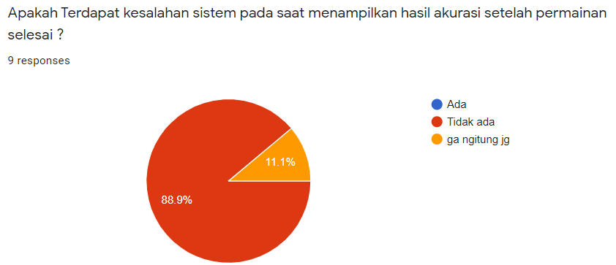

Fig 5.13 Result 13

## Hardware Requirement

Hardware requirement for unit testing is just needing one device such as laptop or PC desktop that can run apache server or XAMPP control panel to run and access the website. For better performance in doing unit testing we recommend to use device with :

* Windows 10 operating system
* Minimum 4GB RAM

# CHAPTER VI

# User Manual

In this chapter, we will explain the ways or stages to access the master typing game website.

* The first thing to do, is to download the XAMPP Control Panel and also the source code for the Master Typing game on Github

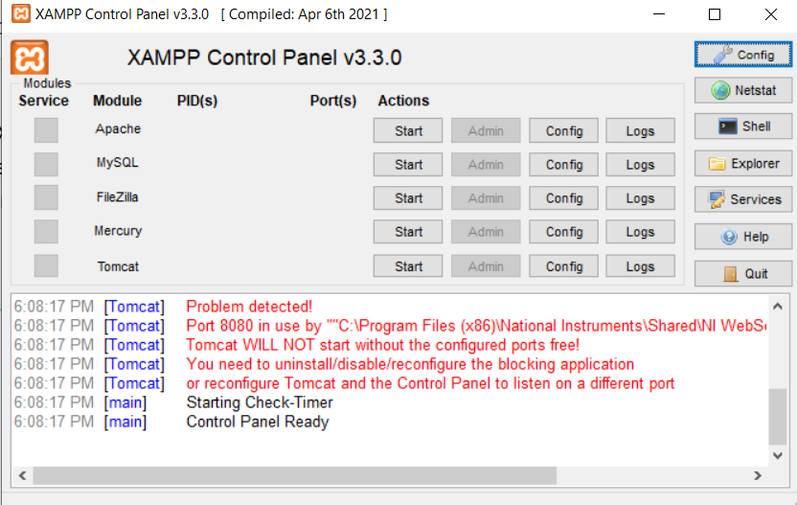

Fig 6.1 User manual 1

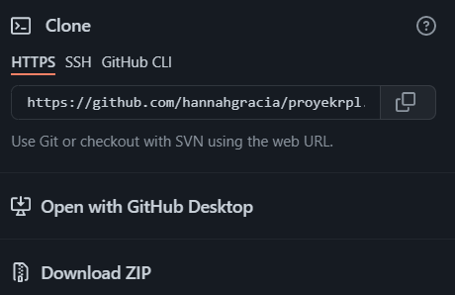

Fig 6.2 User manual 2

* After downloading the source code, extract the file to the file directory : xampp > htdocs

(usually the xampp file directory is in the C file directory)

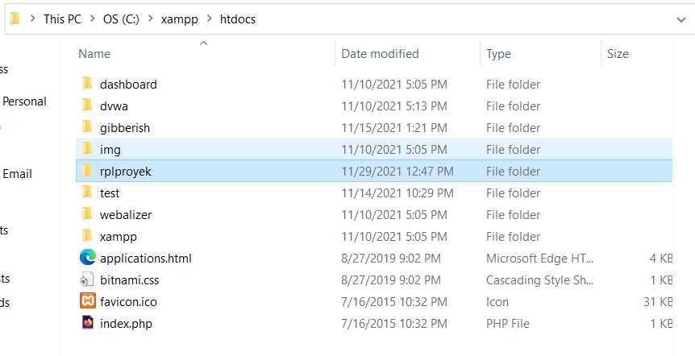

Fig 6.3 User manual 3

* Open “localhost/phpmyadmin” in your browser or click mysql “admin” actions in the xampp control panel

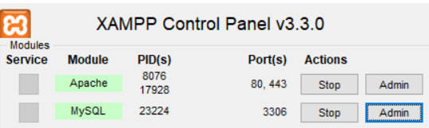

Fig 6.4 User manual 4

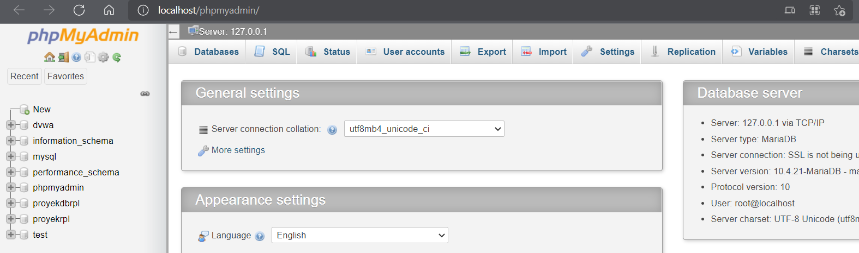

Fig 6.5 User manual 5

* After that create a new database, the database name is released, but to facilitate the configuration that has been done, it is continued to use the database name “projectdbrpl” to match the settings contained in the source code

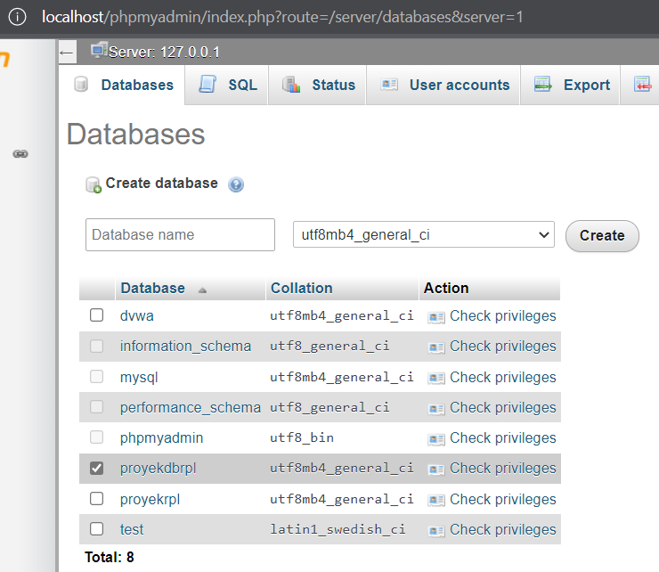

Fig 6.6 User manual 6

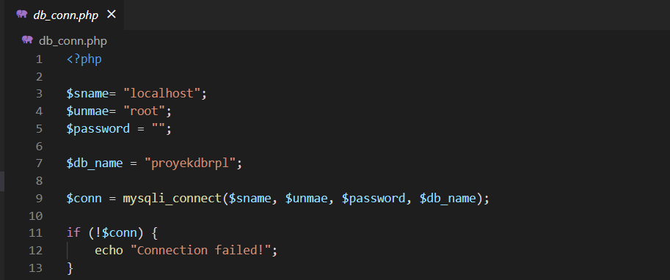

Fig 6.7 User manual 7

The picture above is the db_conn source code which serves to configure the database so that it can be connected. If the database name is different then you can adjust it in this db_conn source code.

* The next step is to import all the .sql files in the “sql” folder into the database. All you have to do is to select import tab menu and then click “Choose File”

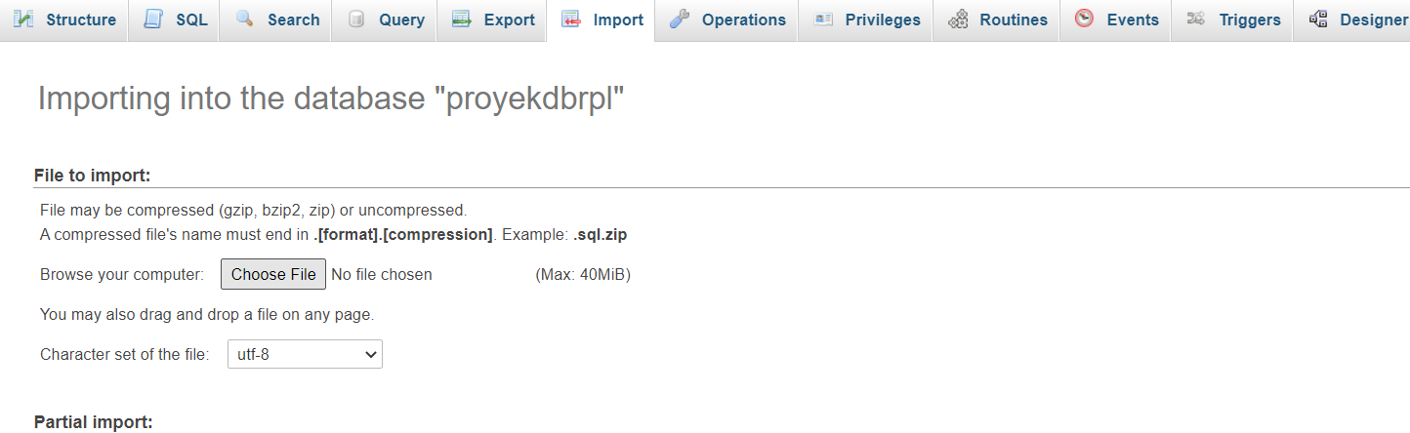

Fig 6.8 User manual 8

And then choose .sql files in the “sql” folders

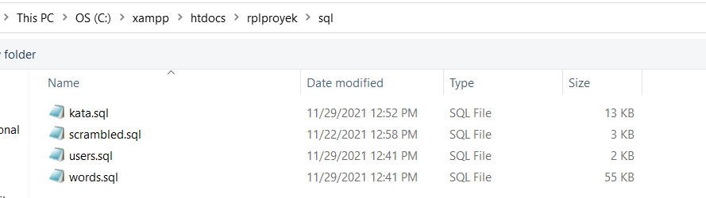

Fig 6.9 User manual 9

After that you can click “Go” in the right edge bottom to input file. Do it for all .sql files.

* Start Apache modules and MySQL modules in XAMPP Control Panel

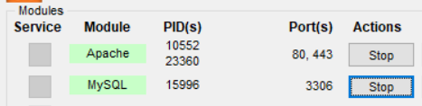

Fig 6.10 User manual 10

If an error occurs, change the port number to the port number that hasn’t been used.

* Type “localhost/rplproyek/index.php” in the web browser to access the website.

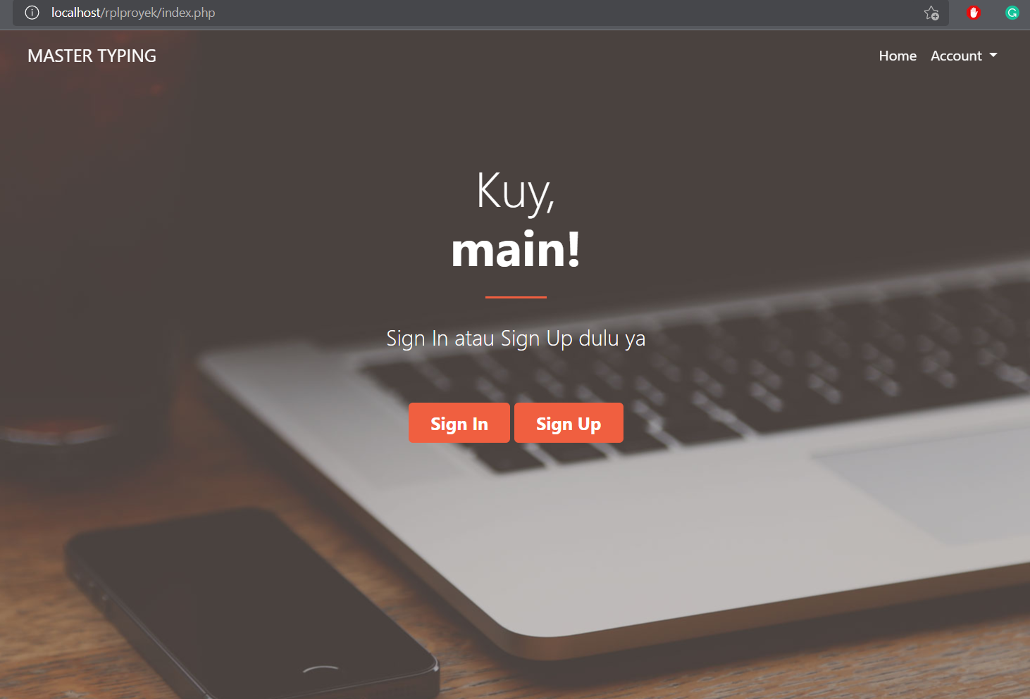

Fig 6.11 User manual 11

* After you access the website, if you don’t have an account you can choose the sign up button to register an account. If you already have an account you can choose the sign in button to login.
* “WPM set goals” in the sign up options are words per minute goals that you have need to be set and also to be the target of your “score”

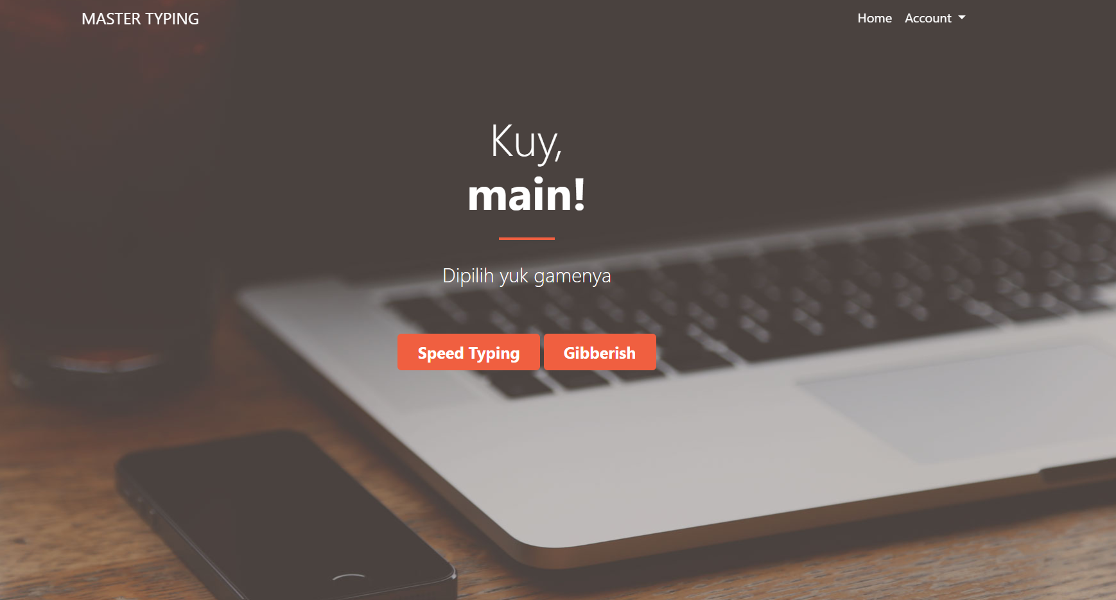

Fig 6.12 User manual 12

* After login an account, all you have to do is to choose the game that you want to play, then choose the language that is available

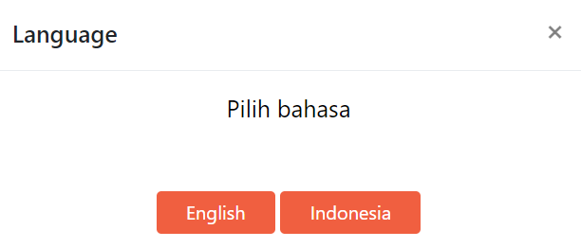  
Fig 6.13 User manual 13

* After choosing the language, all you have to do is to type the answer according to the words in the question box or “Box Soal”

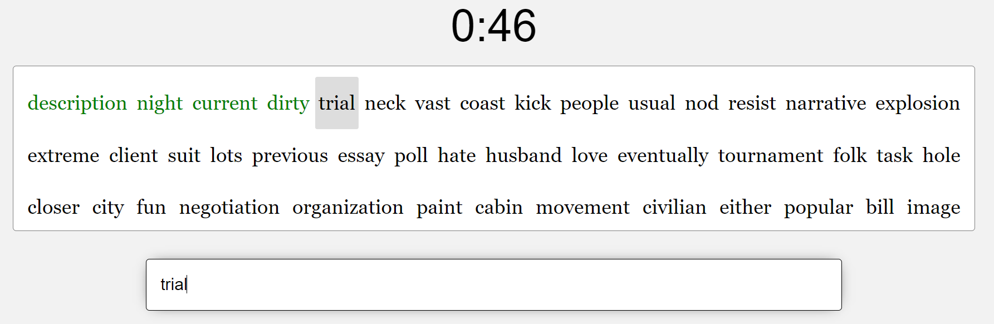

Fig 6.14 User manual 14

* After the time is out score or wpm, wrong words and accuracy statistics will appear

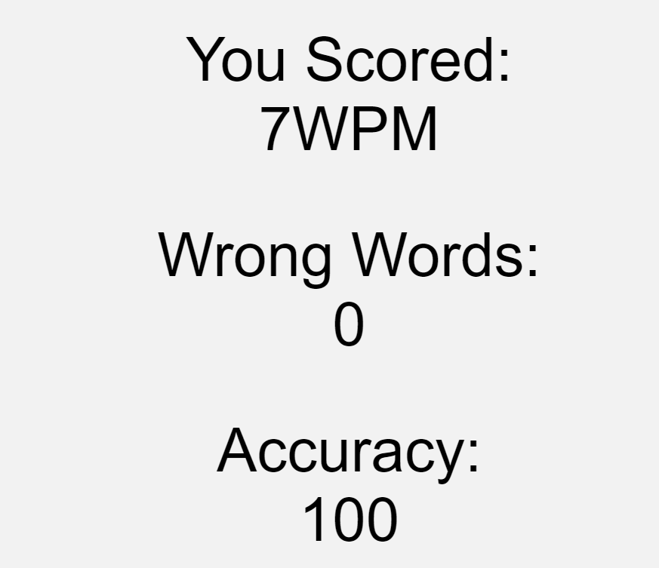

Fig 6.15 User manual 15

* User also can change password in “Change Password” button

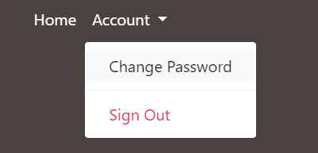

Fig 6.16 User manual 16

# CHAPTER VII

# Closing

7.1 Conclusion

Master Typing Game project is aimed to help people practice their ability to enhance typing accuracy and fastness, both in Indonesian or English words. Furthermore, this game can be used to synchronize the eyes with the hands, because of the gibberish mode that helps by scrambling the words, where the users have to rely solely on seeing the screen without seeing the keyboard if they want to get faster. All in all, our project is made to reach people from all sorts of ages, so that various tasks on the computer can be done faster and more accurately thanks to the improvement in their typing ability.

# REFERENCES

* Garett R, Chiu J, Zhang L, Young SD. A Literature Review: Website Design and User Engagement. Online J Commun Media Technol. 2016 Jul;6(3):1-14. PMID: 27499833; PMCID: PMC4974011.
* <https://www.computerhope.com/jargon/s/software.htm>
* <https://www.geeksforgeeks.org/design-a-typing-speed-test-game-using-javascript/>
* Mariskha Z., Esya A., & Titi A. (2016). Penerapan Program Typing Master dalam Meningkatkan Kecepatan dan Ketelitian Pengetikan 10 Jari Buta. Politeknik Negeri Sriwijaya.